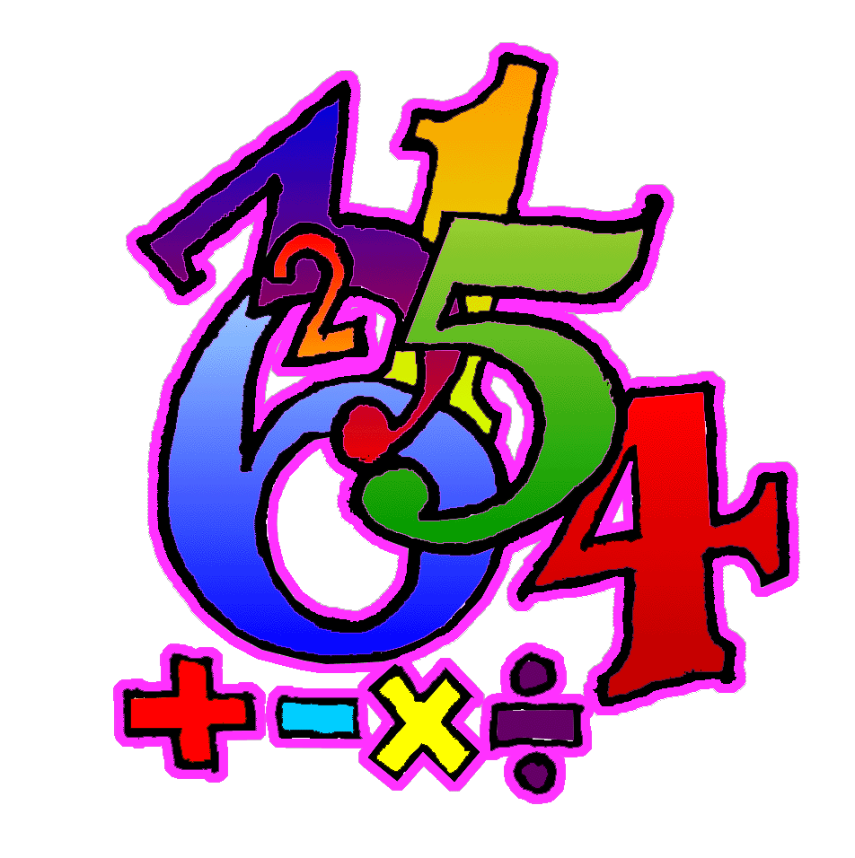
Number bonds to 20 Homework Challenge
15.9.23 | 22.9.23 | 29.9.23 | 06.10.23 | 13.10.23 | 20.10.23
15  0+ 15 = 15  1+14=15  2+13=15  3+12=15  4+11=15  5+10=15  6+9=15  7+8=15  8+7=15  9+6=15  10+5=15  11+4=15  12+3=15  13+2=15  14+1=15  15+0=15 | 16  0+16=16  1+15=16  2+14=16  3+13=16  4+12=16  5+11=16  6+10=16  7+9=16  8+8=16  9+7=16  10+6=16  11+5=16  12+4=16  13+3=16  14+2=16  15+1=16  16+0=6 | 17  0+17=17  1+16=17  2+15=17  3+14=17  4+13=17  5+12=17  6+11=17  7+10=17  8+9=17  9+8=17  10+7=17  11+6=17  12+5=17  13+4=17  14+3=17  15+2=17  16+1=17  17+0=17 | 18  0+18=18  1+17=18  2+16=18  3+15=18  4+14=18  5+13=18  6+12=18  7+11=18  8+10=18  9+9=18  10+8=18  11+7=18  12+6=18  13+5=18  14+4=18  15+3=18  16+2=18  17+1=18  18+0=18 | 19  0+19=19  1+18=19  2+17=19  3+16=19  4+15=19  5+14=19  6+13=19  7+12=19  8+11=19  10+9=9  11+8=9  12+7=9  13+6=9  14+5=9  15+4=9  16+3=9  17+2=9  18+1=9  19+0=9 | 20  0+20=20  1+10=20  2+18=20  3+17=20  4+16=20  5+15=20  6+14=20  7+13=20  8+12=20  9+11=20  10+10=20  11+9=20  12+8=20  13+7=20  14+6=20  15+5=20  16+4=20  17+3=20  18+2=20  19+1=20  20+0=20
Learn your number bonds at home every week. You will be tested on a Friday Morning. This will be in any order.
See examples to support learning on the back

There are many different ways to learn your number bonds:
- Fingers
- Cubes
- Counters
- Any counting equipment
- Patterns
