Pupil premium strategy statement

This statement details our school’s use of pupil premium (and recovery premium for the 2022 to 2023 academic year) funding to help improve the attainment of our disadvantaged pupils.

It outlines our pupil premium strategy, how we intend to spend the funding in this academic year and the effect that last year’s spending of pupil premium had within our school.

School overview
Detail | Data
School name | Winnington Park Primary School and Nursery
Number of pupils in school | 54/389(including nursery)
Proportion (%) of pupil premium eligible pupils | 14%
Academic year/years that our current pupil premium strategy plan covers (3 year plans are recommended) | 1st year 2021 – 2022  2nd year 2022 – 2023  3rd year 2023 – 2024
Date this statement was published | October 2021  Reviewed and edited October 2023
Date on which it will be reviewed | October 2023
Statement authorised by | Rob Cole
Pupil premium lead | Kate Lewis
Governor / Trustee lead | Full governing body
Funding overview
Detail | Amount
Pupil premium funding allocation this academic year | £66,170.00
Recovery premium funding allocation this academic year | £6,126.00
Pupil premium funding carried forward from previous years (enter £0 if not applicable) | £0
Total budget for this academic year  If your school is an academy in a trust that pools this funding, state the amount available to your school this academic year | £72,295.00

Part A: Pupil premium strategy plan

Statement of intent
At Winnington Park, we aim to ensure that all disadvantaged pupils achieve in line with other pupils and that all pupils make the best progress they can. We realise that barriers to learning are as individual as the children. Research (The EEF Guide to Supporting School Planning: A Tiered Approach) shows that the most effective strategy for narrowing the attainment gap of disadvantaged pupils is quality first teaching, followed by targeted support and wider strategies. We have used this to inform our practise. Please see below for further information on our key priorities and how we propose to achieve them.
High-quality teaching is integral to our approach, with a focus on developing specific areas that our children need the most. Our responsive approach enables us to act swiftly when intervention is needed and to adapt our strategy as necessary. All of our funding is targeted at specific areas based on our current cohort of children to ensure they are appropriately challenged and have the resources and skills to achieve their full potential.

Challenges

This details the key challenges to achievement that we have identified among our disadvantaged pupils.
Challenge number | Detail of challenge
1 | School assessments and teacher observations outline a gap between the progress and attainment in reading of children in receipt of the PPG vs their non PP peers.
2 | School assessments and teacher observations outline a gap between the progress and attainment in writing of children in receipt of the PPG vs their non PP peers.
3 | School assessments and teacher observations outline a gap between the progress and attainment in maths of children in receipt of the PPG vs their non PP peers.
4 | Teacher observations and discussions with pupils detail a lack of emotional/ mental wellbeing of some children in receipt of PPG.
5 | School assessments continue to identify gaps in some pupils’ curriculum knowledge due to poor engagement in home learning during school closures in 2020 and 2021. (Laptops were provided to all at this time).

Intended outcomes
This explains the outcomes we are aiming for by the end of our current strategy plan, and how we will measure whether they have been achieved.
Intended outcome | Success criteria
Reading –  Disadvantaged children in all phases will make progress in Reading in line with all other pupils nationally. | - PP children will achieve in line with their peers in Reading in progress and attainment.  - PP children will make at least expected progress in Reading.  - PP children falling behind in Reading will be identified through teacher assessments and reported to SLT in pupil progress meetings.  - PP children in need of additional support will be identified through teacher assessments and reported to SLT in pupil progress meetings.  - Children experience consistent quality first teaching of Reading.
Writing –  Disadvantaged children in all phases will make progress in Writing in line with all other pupils nationally. | - PP children will achieve in line with their peers in Writing in progress and attainment.  - PP children will make at least expected progress in Writing.  - PP children falling behind in Writing will be identified through teacher assessments and reported to SLT in pupil progress meetings.  - PP children in need of additional support will be identified early and adequate support will be put in place to address their needs and accelerate progress.  - Children experience consistent quality first teaching of Writing.
Maths –  Disadvantaged children in all phases will make progress in Maths in line with all other pupils nationally. | - PP children will achieve in line with their peers in Maths in progress and attainment.  - PP children will make at least expected progress in Maths.  - PP children falling behind in Maths will be identified through teacher assessments and reported to SLT in pupil progress meetings.  - PP children in need of additional support will be identified early and adequate support will be put in place to address their needs and accelerate progress.  - Children experience consistent quality first teaching of Maths.
To achieve and sustain improved wellbeing for all pupils in our school, particularly our disadvantaged pupils. | Sustained high levels of wellbeing demonstrated by:  * Qualitative data from student voice, student and teacher observations  * A significant increase in participation in enrichment activities, particularly among disadvantaged pupils
To reengage the children in the learning of all aspects of the curriculum to support and promote their personal development and preparation for the next stage of their education. | - Children will develop their skills and knowledge in each subject area. E.g. Children will build on skills acquired in the previous year group through being taught a tailored curriculum.  - Foundation subject assessments completed half termly by teachers outline any gaps/ areas that need to be covered again.  - Children will develop their resilience through positive feedback from teachers and structured routines. Children are aware of expectations and know what to do to improve their work or when to ask for help.  - Positive teacher/pupil relationships mean issues can be raised and addressed. Worry boxes are available in every classroom.  - Positive attendance figures for disadvantaged children (where figures are in line with their non-disadvantaged counterparts), mean children are provided with a rich and broad curriculum.  - Engaging in curriculum activities provided for all children as part of quality first teaching. Disadvantaged children have trips, swimming and forest schools lessons subsided to ensure all children access all aspects of the curriculum.  - Emotional and mental well-being support for those that need it. E.g. ELSA/ use of nurture room.  - Quality first teaching.

Activity in this academic year
This details how we intend to spend our pupil premium (and recovery premium funding) this academic year to address the challenges listed above.

Teaching (for example, CPD, recruitment and retention)
Budgeted cost: £32,105
Activity | Evidence that supports this approach | Challenge number(s) addressed
Funding towards the salary of an additional teacher in Y6  £29,330.00  (Towards M5 salary - £38,330.00) | High-quality teaching | EEF (educationendowmentfoundation.org.uk)  Based on evidence provided by the EEF, quality first teaching remains as one of our key priorities to achieving success for our disadvantaged children. | 1,2,3,4,5
CGP Booster Books (for Y6)  £1,000.00  Enhancements for our revision programme in preparation for Y6 SATs. | Supporting Revision and the ​‘Seven-step Model.’ ’The EEF’s Julie Kettlewell explains how teachers can scaffold pupils’ revision using the seven-step model.  Books can support teachers to activate prior knowledge and complete guided activities. | 1,5
Y6 step up to maths  £450 | Supporting Revision and the ​‘Seven-step Model.’ ’The EEF’s Julie Kettlewell explains how teachers can scaffold pupils’ revision using the seven-step model.  This model supports activating prior knowledge and working in guided groups to have the best impact of raising pupil attainment. | 3,5
Proud cards used as part of behaviour policy  £450.00 annually | Education Endowment Foundation (EEF) – Improving Behaviour in Schools, 2019  This document outlines that evidence suggests a personalised approach works best. The report recommends six strategies for schools to employ, one of which is to ‘use classroom management strategies to support good classroom behaviour.’ It suggests that reward systems can be effective when used as part of this approach. | 4
1Decision and PSHE resources  £725.00 | EEF_Social_and_Emotional_Learning.pdf(educationendowmentfoundation.org.uk)  There is extensive evidence associating childhood social and emotional skills with improved outcomes at school and in later life (e.g., improved academic performance, attitudes, behaviour and relationships with peers): | 4
Purchase of ‘Little Wandle,’ a DfE validated systematic synthetic phonics programme to secure stronger phonics teaching for all pupils.  £995.00 one off (spent in year 2 of strategy) | Phonics | Toolkit Strand | Education Endowment Foundation | EEF  Phonics approaches have a strong evidence base that indicates a positive impact on the accuracy of word reading (though not necessarily comprehension), particularly for disadvantaged pupils: | 1,2
Rekenrek – maths resource for Y1 and Y2.  £150.00 | EEF_Maths_EY_KS1_Guidance_Report.pdf (d2tic4wvo1iusb.cloudfront.net)  This report recommends to ‘use manipulatives and representations to develop understanding.’ | 3
Purchase of standardised diagnostic assessments for reading, writing and maths.  Tests support teachers to target gaps in subject knowledge.  £1,000.00 Pira | Standardised tests | Assessing and Monitoring Pupil Progress | Education Endowment Foundation | EEF  Standardised tests can provide reliable insights into the specific strengths and weaknesses of each pupil to help ensure they receive the correct additional support through interventions or teacher instruction: | 1,2,3
Giving teacher’s subject leader time- £tbc | Using pupil premium: guidance for school leaders (publishing.service.gov.uk)  Document outlines targeted support such as ‘interventions to support language development, literacy and numeracy’ as a good use of pupil premium funding when targeted at specific children. | 1,2,3,5
Teacher staff training – improving guided writing in the classroom  Paid in year 2 of strategy | Using pupil premium: guidance for school leaders (publishing.service.gov.uk)  This document recommends ‘professional development on evidence based approaches’ as an effective use of pupil premium funding when targeted at a specific area. | 2

Targeted academic support (for example, tutoring, one-to-one support structured interventions)
Budgeted cost: £11,466
Activity | Evidence that supports this approach | Challenge number(s) addressed
ELSA  ELSA training  £350 termly =  £1,050 | ‘The link between pupil health and wellbeing and attainment A briefing for head teachers, governors and staff in education settings’ Public Health England  Evidence in this report suggests learning social and emotional skills can have a positive impact on attainment. | 4 (Main challenge addressed)  1,2,3,5 (Children who are emotionally supported have a better chance of accessing the curriculum)
Dyslexia teacher x2 mornings a week  £10,416.00 | Using pupil premium: guidance for school leaders (publishing.service.gov.uk)  Document outlines targeted support such as ‘interventions to support language development, literacy and numeracy’ as a good use of pupil premium funding when targeted at specific children. | 1,2
Wellcom  £0 | Oral language interventions | EEF (educationendowmentfoundation.org.uk)  ‘There is evidence to suggest that pupils from lower socioeconomic backgrounds are more likely to be behind their more advantaged counterparts in developing early language and speech skills, which may affect their school experience and learning later in their school lives.  Given that Oral language interventions can be used to provide additional support to pupils who are behind their peers in oral language development, the targeted use of approaches may support some disadvantaged pupils to catch up with peers, particularly when this is provided one-to-one.’  Children identified as needing support in this area have access to the resources they need. Working at the age related expectation in speech and language gives children a better chance of achieving the age related expectations in other areas of the curriculum. | 1,2,5
Family support worker | Working with Parents to Support Children's Learning | EEF (educationendowmentfoundation.org.uk)  This EEF guidance report reviews the best available research to offer schools and teachers four recommendations to support parental engagement in children’s learning.  ‘Parents play a crucial role in supporting their children’s learning, and levels of parental engagement are consistently associated with better academic outcomes. Evidence from our Teaching and Learning Toolkit suggests that effective parental engagement can lead to learning gains of +3 months over the course of a year.’ | 1,2,3,4,5

Wider strategies (for example, related to attendance, behaviour, wellbeing)
Budgeted cost: £27,712.50
Activity | Evidence that supports this approach | Challenge number(s) addressed
Winnington Winners (before and after school club)  £26,491.50 – This was the figure for 2022-2023 provision | Using pupil premium: guidance for school leaders (publishing.service.gov.uk)  School breakfast clubs are listed as an example of how the PPG can be spent to support attendance/ have a positive impact on a child’s success in school by supporting families financially. | 1,2,3,5
Subsided Residential Y3  £125 | Teaching a broad and balanced curriculum for education recovery’ DfE, 2021  This document outlines the importance of including educational visits and visitors to the school as an integral part of providing a broad and balanced curriculum. Our funding supports disadvantaged children to access an enriched curriculum where they have the chance to experience learning out of the classroom supporting children’s emotional well-being. Children have the opportunity to fulfil missed life experiences. | 4
Subsided Residential Y4  £196 |  | 4
Subsided Residential Y6  £900.00 |  | 4

Total budgeted cost: £ 72,283.50
£72,295 budget.

Part B: Review of outcomes in the previous academic year

Pupil premium strategy outcomes
This details the impact that our pupil premium activity had on pupils in the 2021 to 2022 academic year.
Impact report PPF (2022-23)

Intended outcome | Success criteria evaluation
Reading –  Disadvantaged children in all phases will make progress in Reading in line with all other pupils nationally. | - PP children will achieve in line with their peers in Reading in progress and attainment.  - PP children will make at least expected progress in Reading.  - PP children falling behind in Reading will be identified through teacher assessments and reported to SLT in pupil progress meetings.  - PP children in need of additional support will be identified early and adequate support will be put in place to address their needs and accelerate progress.  - Children experience consistent quality first teaching of Reading.
Writing –  Disadvantaged children in all phases will make progress in Writing in line with all other pupils nationally. | - PP children will achieve in line with their peers in Writing in progress and attainment.  - PP children will make at least expected progress in Writing.  - PP children falling behind in Writing will be identified through teacher assessments and reported to SLT in pupil progress meetings.  - PP children in need of additional support will be identified early and adequate support will be put in place to address their needs and accelerate progress.  - Children experience consistent quality first teaching of Writing.
Maths –  Disadvantaged children in all phases will make progress in Maths in line with all other pupils nationally. | - PP children will achieve in line with their peers in Maths in progress and attainment.  - PP children will make at least expected progress in Maths.  - PP children falling behind in Maths will be identified through teacher assessments and reported to SLT in pupil progress meetings.  - PP children in need of additional support will be identified early and adequate support will be put in place to address their needs and accelerate progress.  - Children experience consistent quality first teaching of Maths.
To achieve and sustain improved wellbeing for all pupils in our school, particularly our disadvantaged pupils. | Sustained high levels of wellbeing demonstrated by:  * Qualitative data from student voice, student and teacher observations  * A significant increase in participation in enrichment activities, particularly among disadvantaged pupils
To reengage the children in the learning of all aspects of the curriculum to support and promote their personal development and preparation for the next stage of their education. | - Children will develop their skills and knowledge in each subject area. E.g. Children will build on skills acquired in the previous year group through being taught a tailored curriculum.  - Foundation subject assessments completed half termly by teachers outline any gaps/ areas that need to be covered again.  - Children will develop their resilience through positive feedback from teachers and structured routines. Children are aware of expectations and know what to do to improve their work or when to ask for help.  - Positive teacher/pupil relationships mean issues can be raised and addressed. Worry boxes are available in every classroom.  - Positive attendance figures for disadvantaged children (where figures are in line with their non-disadvantaged counterparts), mean children are provided with a rich and broad curriculum.  - Engaging in curriculum activities provided for all children as part of quality first teaching. Disadvantaged children have trips, swimming and forest schools lessons subsided to ensure all children access all aspects of the curriculum.  - Emotional and mental well-being support for those that need it. E.g. ELSA/ use of nurture room.  - Quality first teaching.

The grid below outlines the impact of how we spent our pupil premium (and recovery premium funding) in the academic year 2022-2023 and how they have contributed towards our intended outcomes. These results have influenced our strategy statement for the next academic year (2023 – 2024), to ensure we are targeting out funding in the most effective areas.
Activity | Evaluation – Was this effective? Should we continue spending in this area?
Funding towards the salary of an additional teacher in Y5 and Y4 (43 pupils) | Key headlines from the Y5 data below:  - ALL disadvantaged children made expected progress or better in reading and writing.  - In maths, 27% of disadvantaged children (3 children), made less than expected progress. Teacher feedback said these children lacked in confidence in maths. One in particular achieved the expected level in class work, but struggled to complete PUMA assessments. All three children received more teacher time in class. A barrier to mastery of number was their reading level. Additional teacher time supported them with this.  - Disadvantaged children outperformed their peers in reading, with a greater percentage of disadvantaged children achieving better than expected progress.  Year 5 PROGRESS data (reading, writing and maths combined)  Disadvantaged children  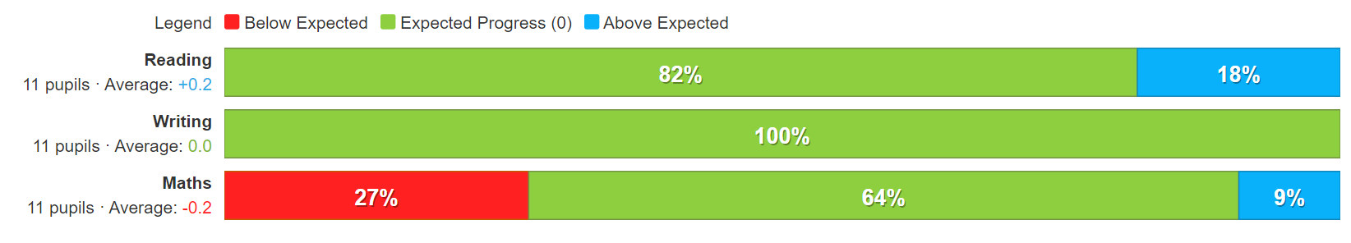  Year 5 PROGRESS data (reading, writing and maths combined)  Non disadvantaged children  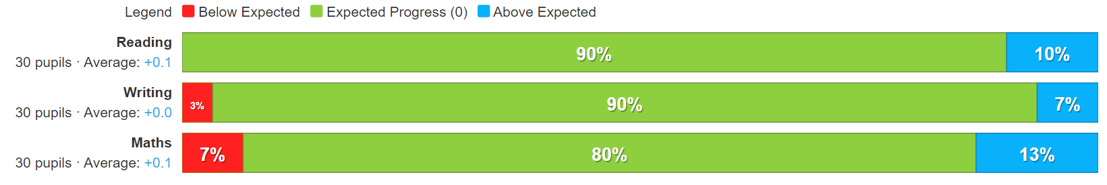  Key headlines from Year 4 data shown below:  - In reading and maths, 17% (1 child) didn’t make expected progress. This was the same child. Teacher feedback said the child was part of small teacher led group work in English and maths. The child also received additional reading support weekly.  - ALL disadvantaged children made expected progress in writing.  - Non-disadvantaged children slightly outperformed their disadvantaged peers, with some children achieving above the expected progress.  Year 4 PROGRESS data (reading, writing and maths)  Disadvantaged children  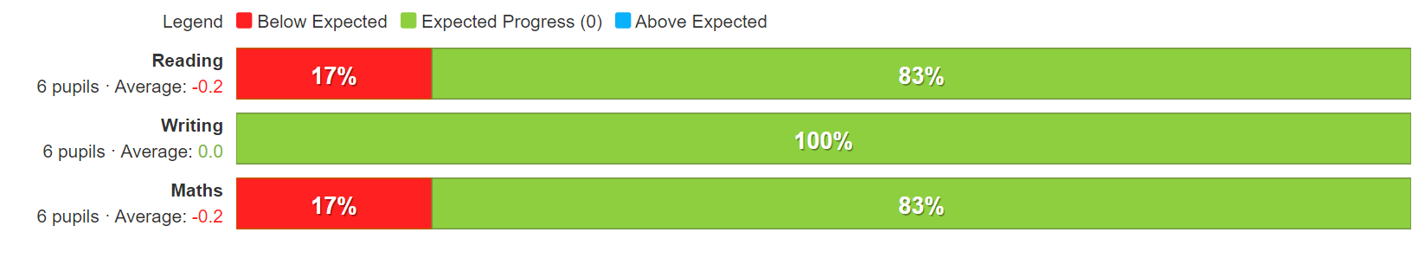  Year 4 PROGRESS data (reading, writing and maths)  Non disadvantaged children  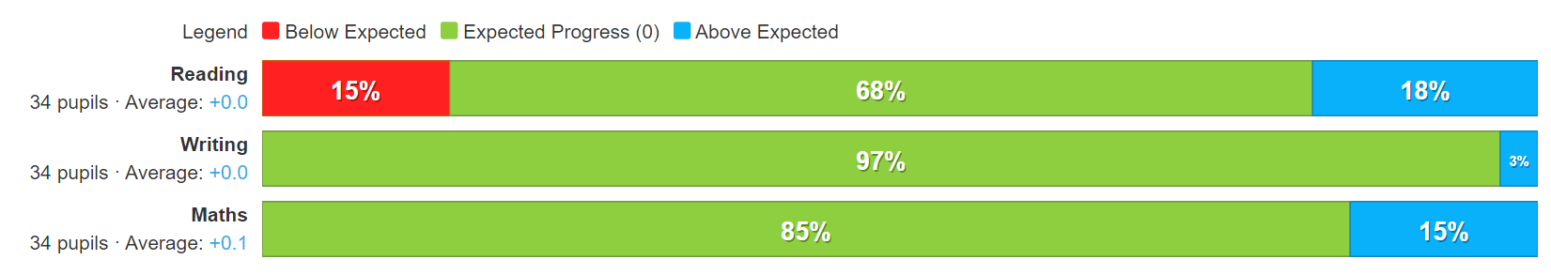  Evaluation: Having an additional teacher in these year groups has made a positive impact on disadvantaged and non-disadvantaged children, allowing more ‘teacher time’ for the children that need it. This is evident through the support the teachers have provided as part of their quality first teaching.
CGP Booster Books (for Y6)  Enhancements for our revision programme in preparation for Y6 SATs. | Year 6 teachers commented that these books had been extremely useful. Children were set pages to complete as homework that they then reviewed every Friday in class. The layout mirrors the types of questions the children would tackle in SATs papers, preparing them well.  As shown in the figure below, ALL disadvantaged children in year 6 made expected progress or better.  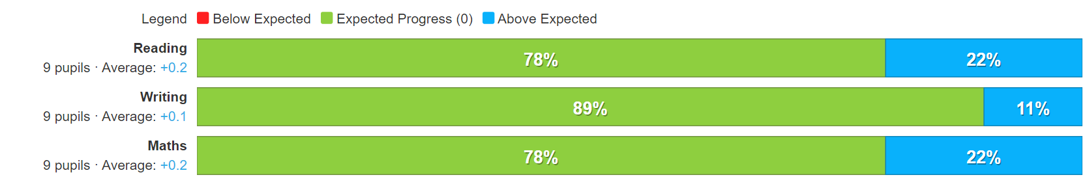  Evaluation: This has been an effective enhancement for our revision programme in preparation for Y6 SAT
Y6 step up to maths  £450 | This intervention was discontinued this year and did not take place.
Proud cards used as part of behaviour policy | Feedback from proud cards is positive, from children, staff and parents alike. Staff have reported a positive reception from children receiving proud cards, noting that it encourages children to achieve ‘above and beyond.’  Pupil comments:  ‘I love it when I get a proud card!’ Y2 pupil  ‘I’ve got three proud cards already this year!’ Y2 pupil  Parent comments  ‘______ loves it when he gets a proud card. He has made a collection of them and keeps them by his bed.’ Year 2 parent  ‘I know he’s had a good day when he gets one of those!’ Year 2 parent  Evaluation: Proud cards remain an integral part of our behaviour policy and are widely successful. Positive behaviour for learning is integral to a successful learning environment for all children.
1Decision and PSHE resources | Well received by teaching staff delivering the content. Subject leader has reported the site easy to navigate with lots of supporting resources. When asked how PSHE lessons make them feel, pupils responded: KS1- ‘It makes me feel happy. I’m happy that they listen to me.’ KS2- ‘I feel happy. I like to understand why they don’t agree if they don’t. It’s interesting to listen to what other people think.’  KS1- Yes they always listen. Yes.  KS2- Yes they do. Yes everyone listens to each other. Yes they listen and I listen to what they think. Some people might agree or some might not agree but that’s all ok.’  Evaluation: 1Decision supports children socially and emotionally. This is one of the success criteria for our last ‘intended outcome’ focusing on children’s own personal development and has been successful this year.
Purchase of ‘Little Wandle,’ a DfE validated systematic synthetic phonics programme to secure stronger phonics teaching for all pupils. | 72% pass rate this year. Although this down on last year, there is significantly more children with SEND/ additional needs completing the check this year.  Evaluation: Continue to implement scheme.
Rekenrek – maths resource for Y1. | ALL disadvantaged children achieved expected progress or better in maths (as shown below).  Teacher comments: ‘Once the children were used to it, the programme really ensured the children could consolidate their learning.’ Y1 teacher  Evaluation: The evidence supports this as an effective expenditure, especially as this one-off spend for a resource that will be used every ye
Purchase of standardised diagnostic assessments for reading, writing and maths.  Tests support teachers to target gaps in subject knowledge. | Standardised tests | Assessing and Monitoring Pupil Progress | Education Endowment Foundation | EEF  As the EEF report above outlines, standardised tests can provide reliable insights into the specific strengths and weaknesses of each pupil to help ensure they receive the correct additional support through interventions or teacher instruction. Teachers at Winnington have used the results from these tests to inform teaching and address gaps in learning.  Evaluation: This has been an informative assessment tool and effective in identifying specific gaps in learning for all children.
Giving teacher’s subject leader time- | Teacher comments:  ‘It has been invaluable to me to complete my additional duties.’ Year 1 teacher.  Evaluation: Supporting teachers to provide an enhanced and diverse curriculum is a strategy that links directly to ‘quality first teaching,’ which is an integral part of our strategy to support our disadvantaged learners. This is an effective use of funds.
Teacher staff training – improving guided writing in the classroom | Teachers have received training to improve the teaching of writing in the classroom. This supports our aim to provide ‘quality first teaching.’  The figures below illustrate the progress of all disadvantaged children this year (after training), compared to last year. The figures show an improvement in the progress of disadvantaged writers, with 90% of disadvantaged children achieving expected progress or better, compared to 87% the previous year. 6% more children made greater than expected progress this year.  Overview of progress in writing for disadvantaged children in 2022-23 (this year)  Overview of progress in writing for disadvantaged children in 2021-22 (last year)  Evaluation: Teacher training has proved an effective use of pupil premium funding, directly affecting the progress of disadvantaged children.
Annual use of Nurture Room supported by x2 qualified TAs.  Children identified by their class teacher needing additional emotional/social support are able to access this resource. Children are supported emotionally and socially, enabling them a better chance of accessing the curriculum. | Evaluation: Although the nurture room has been an effective resource for our vulnerable children in the past, unfortunately at the end of this year and for the foreseeable future, we are unable to use it due to new fire safety regulations. As a result, we will not be continuing to spend the budget in this area in the year 22-23.
ELSA  ELSA training | Feedback from ELSA has been extremely positive from children, parents and ELSA teachers.  Evaluation: ELSA has been invaluable in supporting our most vulnerable children, including our looked after children, who have been or are currently living in care. This has been an effective use of pupil premium funding to support the emotional needs of our most vulnerable children. Out of 21 children on the vulnerable list, 14 also appear on the disadvantaged register.
Dyslexia teacher x2 mornings a week | A specialist dyslexia teacher works with KS2 pupils. A TA supports her work during the week in class so this support continues all week not just on her 2 mornings. She is able to advise staff on how best to support these children when she is not there. Our SENDCo noted that children are being provided with sensory strategies on how to cope back in class.  Evaluation: Having a specialist dyslexia teacher has provided invaluable support for children with SEND, including disadvantaged children. This support ensures these children have the support they require in and out of the classroom.
Wellcom | Wellcom has a huge impact on children’s understanding of language in EYs. Historically children on entry have low speech and language skills. SALT has said that including Wellcom assessments on speech and language referrals helps to pin point their interventions. Children are assessed on entry to Nursery and throughout their EYs education. Starting Wellcom in Nursery results in the majority of children starting Reception age related in their understanding of language.  Evaluation: Wellcom remains an effective assessment tool in early years.
Family support worker | Evaluation: Out of 21 children on the vulnerable list, 14 also appear on the disadvantaged register. Supporting our most vulnerable families remains an important aspect of our pupil premium expenditure.
Winnington Winners (before and after school club)  £12,151.21 | School breakfast clubs are listed as an example of how the PPG can be spent to support attendance/ have a positive impact on a child’s success in school by supporting families financially - Using pupil premium: guidance for school leaders (publishing.service.gov.uk).  Evaluation: ACTION – parent questionnaire
Subsided Residential Y3  £150 | Our funding supports disadvantaged children to access an enriched curriculum where they have the chance to experience learning out of the classroom supporting children’s emotional well-being as well as supporting families financially.  Evaluation: ACTION - Parent questionnaire
Subsided Residential Y4  £175 | As above
Subsided Residential Y6  £765  +£205 | As above
Half termly trips | Our trips and visitor experiences and cooking club were hugely successful this year. Children had the chance to experience learning out of the classroom, supporting emotional well-being as well as providing a fun experience. Examples include a boat ride at Anderton Boat Lift  Pupil voice examples:  ‘I’ve never been on a boat before, this is my first boat ride.’ KS2 pupil  ‘This mint smells like toothpaste’ KS2 pupil at cooking club  However, our curriculum can support this through half termly trip opportunities provided to every child.

Externally provided programmes
Please include the names of any non-DfE programmes that you purchased in the previous academic year. This will help the Department for Education identify which ones are popular in England
Programme | Provider
Step up to maths | First 4 maths

Service pupil premium funding (optional)
For schools that receive this funding, you may wish to provide the following information:
Measure | Details
How did you spend your service pupil premium allocation last academic year? | n/a
What was the impact of that spending on service pupil premium eligible pupils? | n/a

Further information (optional)

