Winnington Park

Curriculum Map

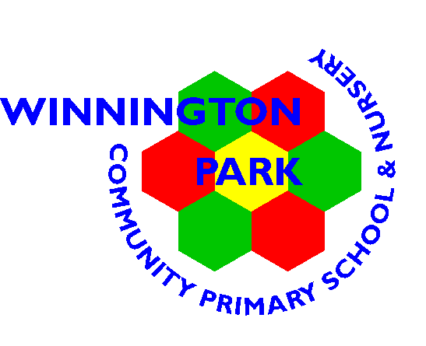
Winnington Park Primary School and Nursery

The Winnington Park Pledge

The Winnington Park Pledge is a commitment that during the course of their time at our school, children will have the opportunity:
- To learn to play and perform a musical instrument
- To visit a theatre, museum or art gallery
- To travel on a bus or a train
- To have the opportunity to participate in competitive sports
- To attend a residential visit
- To participate in democratic elections for membership of the Winnington Park School Council
- To learn to ride a bike safely on the local roads
- To visit a different place of worship each year
- To learn about inspiring individuals including artists, composers and scientists

Value | Autumn 1 | Autumn 2 | Spring 1 | Spring 2 | Summer 1 | Summer 2
Value | Aspire | Safe | Respect | Trust | Kind | Proud

 | EYFS *two-year cycle | Year 1 | Year 2 | Year 3 | Year 4 | Year 5 | Year 6
Educational visits and  Enrichment experiences | Animal linked visit / workshop  Bikeability  Celebrations e.g. Chinese New Year, Eid, Diwali, Christmas, Harvest, Easter, Remembrance  Grandparents Day  Stay and Play | Local Walk  Toy workshop  Visit to the beach | Art Gallery  Trip on a train (Chinese Restaurant)  Chester Zoo | Residential  Egyptian Day  World Museum for Stone Age  Lion Salt Works | Residential  Visit to Roman Chester and the Grosvenor Museum  Walk around Tatton Park  Maya experience visitor to school  Let’s Walk  Northwich Art | Halle  Bikability  Yorvik Centre: York  Northwich Sings | Residential  London
Places of worship | Hartford Methodist Church | St John’s Church, Hartford | Synagogue | Buddhist Temple | Hindu Temple | Gurdwara | Mosque
No Outsiders | The Family Book  ‘To understand that all families are different’  Mommy, Mamma and Me  ‘To celebrate my family’  Blue Chameleon  ‘To make friends with someone different  ’You Choose  ‘To say what I think’  Red Rockets and Rainbow Jelly  ‘To understand that it’s okay to like’ | Elmer  ‘To like the way I am  ’Ten Little Pirates  ‘To play with girls’ and boys’  That’s Not How You Do It  ‘To accept that people are different’  Max the Champion  ‘To understand that our bodies work in different ways’  My World, Your World  ‘To understand that we share the world with lots of people’ | The Great Big Book of Families  ‘To understand what diversity is’ The First Slodge  ‘To understand how we share the world’ The Odd Egg  ‘To understand what makes someone feel proud’ What the Jackdaw Saw  ‘To communicate in different ways’ Blown Away  ‘To be able to work with everyone in my class’ | We’re All Wonders  ‘To use my pupil voice’  This is Our House  ‘To understand what discrimination means’  Two Monsters  ‘To find a solution to a problem’  The Hueys in The New Jumper  ‘Use strategies to help someone who feels different’  The Spots and the Dots  ‘To know what prejudice is and where it comes from’ | Dogs Don’t Do Ballet  ‘To know when to be assertive’  King and King  ‘To understand why people choose to get married’  The Way Back  ‘To overcome language as a barrier’  The Flower  ‘To ask questions’  Red: A Crayon’s Story  ‘To be who you want to be’ | Where the Poppies Now Grow  ‘To learn from our past’  Rose Blanch  ‘To justify my actions’  How to Heal a Broken Wing  ‘To recognise when someone needs help’  The Cow Who Climbed a Tree  ‘To exchange dialogue’  And Tango Makes Three  ‘To accept people who are different from me’ | Mr Princess Boy  ‘To promote diversity’  The Thing  ‘To welcome difference and to stand up to discrimination’  The Island  ‘To challenge the causes of racism’  Leaf  ‘To overcome fears about difference’  Dreams of Freedom  ‘To recognise my freedom’
Inspiring individuals | *lead by the children’s interests | George Mottershead  Piet Modrian  Wassily Kandinsky | Charles Macintosh  L.S. Lowry  Andy Goldsworthy | Mary Anning  Giuseppe Arcimboldo | Thomas Edison  Lewis Howard Latimer  Van Gogh  Banksy | David Attenborough  Jane Goodall  Mae Jemison  Jill Townsley  Alvaro Suarez Vertiz  Georgia O’Keeffe | Charles Darwin Alfred Wallace  Hans Holbein  Roy Litchenstein

Composers | Autumn 1 | Autumn 2 | Spring 1 | Spring 2 | Summer 1 | Summer 2
Composers | G.F. Handel – Messiah  Ludwig Beethoven - 5th Symphony | Vivaldi – Four Seasons  Benjamin Britten  Edward Elgar | Johann Bach  Wolfgang Mozart  Piotr Tchaikovsky | Franz Shubert  Franz Liszt  Maurice Ravel | Claude Debussy  Clara Schumann  Amy Beach | Judith Weir  Steve Reich  John Adams

Winnington Park Primary School and Nursery

 | Early Years Foundation Stage | Key Stage 1 |  | Key Stage 2
 | Reception | Year 1 | Year 2 | Year 3 | Year 4 | Year 5 | Year 6
Autumn |  | Houses and homes | The Great Fire of London | Ancient Egypt | The Roman Empire | Raging Rivers | WWII
Spring |  | Toys | Let’s go to China | The Stone Age | The Mayas | The Vikings and Anglo Saxons | The Royals
Summer |  | On my doorstep | Great Explorers | A pinch of salt | British Transport | Ancient Greece | Life beyond Winnington Park

