

|  |  |  |  |  |  |
| --- | --- | --- | --- | --- | --- |
| ***ASPIRE*** | ***SAFE*** | ***TRUST*** | ***RESPECT*** | ***KIND*** | ***PRIDE*** |

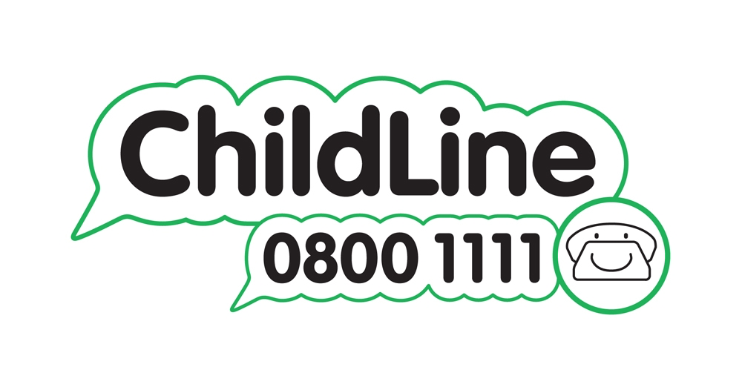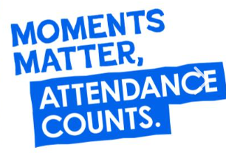

*Wednesday 18th September*

Dear Parents and Carers,

**Year 4 Roman Chester Trip**

As part of our Romans topic this term, we have planned a trip to Chester on Monday 21st October. This visit will include time at the Grosvenor Museum in Chester where the children will take part in a Roman workshop. We will learn about why the Romans came to Britain and specifically Chester. The children will look at real and replica artefacts focusing on three areas: archeology, building Roman Chester and the Roman world. We will also have a chance to practice being in the Roman army by carrying shields and marching in formation to the amphitheatre in Chester.

We will leave school at 9.30am and travel by coach to the museum returning to school for 3.15pm. Children will need to bring a packed lunch in a disposable bag, a drink and they will need to wear their school uniform and coat as we will be outside for part of the day.

If you would like to order a school packed lunch for your child, all orders must be made by Friday 11th October using the reply slip below. Following Natasha’s Law, packed lunches cannot be ordered from the kitchen on the day of the trip.

The cost of this trip will be £18.25 and you can pay via Gateway. We appreciate this is an additional cost to the Year 4 Residential and we are happy to facilitate payment plans for those families who request them. Please contact Mrs Wood in the school office to organise this.

Please complete the slip below and return to school as soon as possible.

Your sincerely,

Mrs Conheeney and Mrs Worsley

----------------------------------------------------------------------------------------------------------------------------------------

**Y4 Roman Chester trip**

I give permission for my child __________________________ to go on the school trip to Chester on Monday 21st October.

I do/do not give permission for my child to have their photograph taken and used on the school website or on school social media pages.

My child will/will not need a lunch ordering for them. They would like ham/cheese/tuna

I am able/not able to come on this trip and support the children. We will confirm with you if we need you to come.

I have paid £18.25 on Gateway for this trip.

Signed ______________________________ Emergency Contact Number ________________________

Winnington Park Primary School and Nursery, Firdale Road, Winnington, Northwich, Cheshire, CW8 4AZ

Tel: 01606 74371 email: admin@winningtonpark.cheshire.sch.uk website: www.winningtonpark.cheshire.sch.uk

Headteacher: Mr Rob Cole email: head@winningtonpark.cheshire.sch.uk

