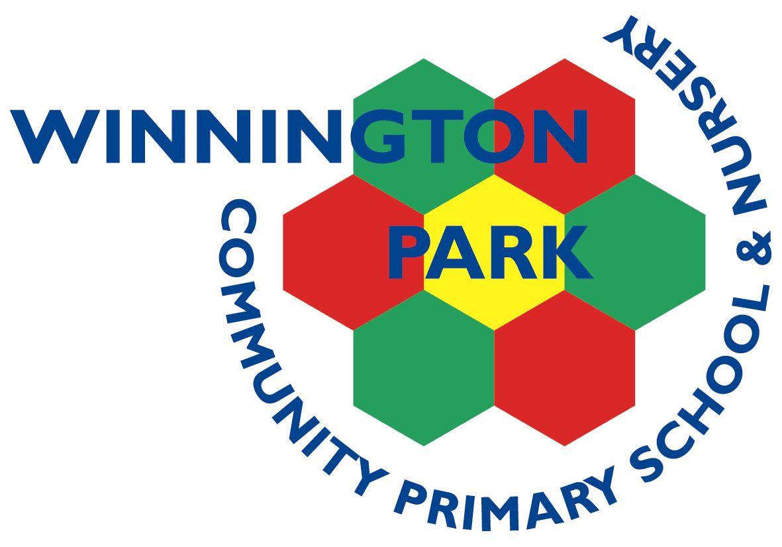

|  |  |  |  |  |  |
| --- | --- | --- | --- | --- | --- |
| ***ASPIRE*** | ***SAFE*** | ***TRUST*** | ***RESPECT*** | ***KIND*** | ***PRIDE*** |

Monday 17th June 2024

Dear Parents, Carers and Children,

**Year 6 (2024-25) Residential Visit to the Conway Centre October 2024**

We value the ability to provide pupils with experiences that will enhance the curriculum and provide opportunities to develop skills and learning that we cannot offer in school. We have therefore arranged a two-night residential trip for your child’s year group at the beginning of the next school year. The children will be able to participate in Abseiling, Canoeing, Zip Wires, Rope Courses, Sports, Camp Fires, Bush Craft and Team Building Activities and will have a fantastic time bonding with their friends and establishing their relationships with their new teachers in preparation for the important year ahead.

The residential will take place from Wednesday 16th October to Friday 18th October, at The Conway Outdoor Activity Centre, Anglesey, North Wales.

All activities are led by appropriately qualified instructors who work at the centre and a full and thorough risk assessment following wider advice on visiting indoor and outdoor venues will be completed in conjunction with the centre. The strictest health and safety measures will be followed to ensure the safety and wellbeing of all pupils. Children will travel on a coach with seatbelts, with a fully qualified and insured driver.

Further information about how the trip will be organised is on the additional information pages. This has always been a very successful trip and the children have a brilliant time. There will be a parents’ information meeting in September to share further information with you.

The cost of the trip is £224.00 per pupil (£110.75 accommodation and food; £24.25 transport; £89.00 activities). I appreciate this is a considerable cost, so we are sending the information out to you as soon as we have been able to confirm that the trip will be able to go ahead so you can spread the cost.

Please complete, sign and return the consent form, and pay an initial deposit of £44 on Gateway by Monday 24th June 2024. If we do not receive sufficient deposits, this residential trip may not be able to go ahead. If you have any questions, please contact school. For any finance queries, including the setting up of a payment plan to spread the cost, please contact Mrs Wood in the office.

Gateway payments = 1 x £44.00 in June then 4 x £45.00 July – October 2024

Yours sincerely,

Mr Rob Cole

(*Headteacher*)

Winnington Park Primary School and Nursery, Firdale Road, Winnington, Northwich, Cheshire, CW8 4AZ

Tel: 01606 74371 email: admin@winningtonpark.cheshire.sch.uk website: www.winningtonpark.cheshire.sch.uk

Headteacher: Mr Rob Cole email: head@winningtonpark.cheshire.sch.uk



