

|  |  |  |  |  |  |
| --- | --- | --- | --- | --- | --- |
| ***ASPIRE*** | ***SAFE*** | ***TRUST*** | ***RESPECT*** | ***KIND*** | ***PRIDE*** |

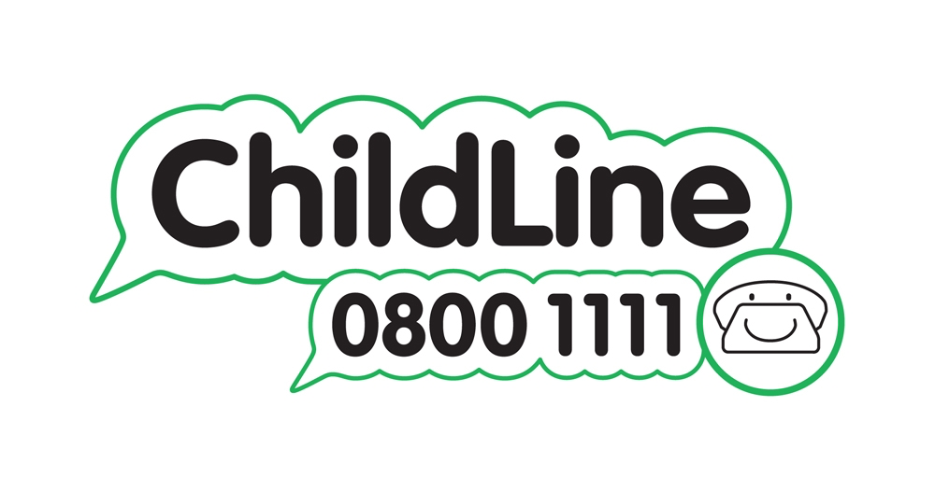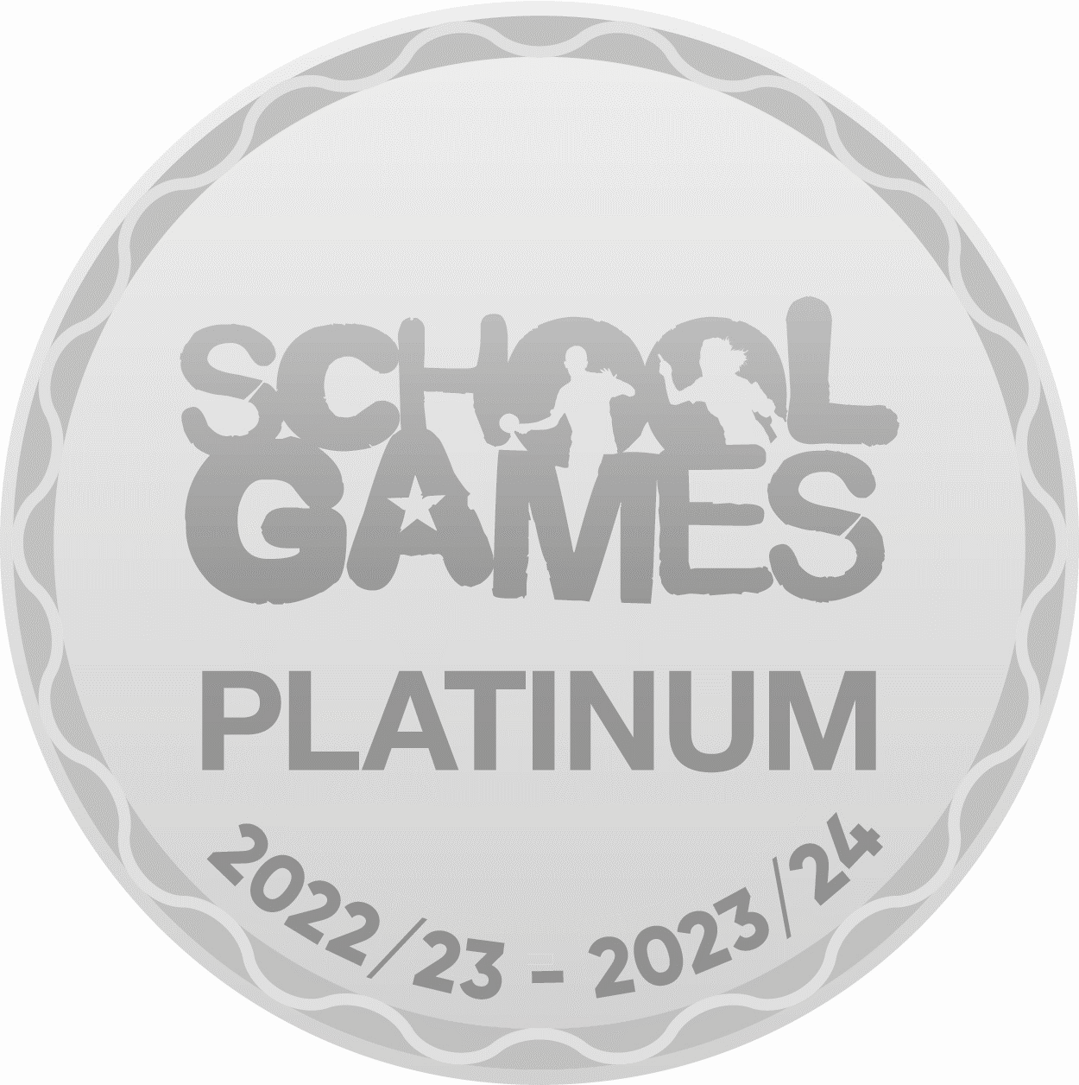

Winnington Park Primary School and Nursery, Firdale Road, Winnington, Northwich, Cheshire, CW8 4AZ

Tel: 01606 74371 email: admin@winningtonpark.cheshire.sch.uk website: www.winningtonpark.cheshire.sch.uk

Headteacher: Mr Rob Cole email: head@winningtonpark.cheshire.sch.uk



*Tuesday 8nd October 2024*

Dear Parents and Carers,

Y5/6 Mixed Football Competition

Your child has been selected to represent Winnington Park at the Year 5/6 mixed football competition on Tuesday 22nd October at Hartford High School. The competition will run from 2pm – 4pm.

Children should wear their PE kit with appropriate footwear. Please note studded boots are not permitted. A water bottle will also be essential.

We will be walking up to Hartford High School in the afternoon, but your child will need to be collected from Hartford High School at 3.45pm. Parents are invited to attend, however will not be allowed onto the premises of the high school until 3:30pm.

If you wish your child to take part, please fill in the slip below and return to school.

Yours sincerely,

Mrs Hainsworth, Mrs Ford and Mrs Williams

…………………………………………………………………………………………………………………………

Year 5/6 Mixed Football Competition

Name:……………………………………………………………….. Class:……………………….

I give permission for my child to attend the Year 5/6 Mixed Football Competition on Tuesday 22nd October 2024.

Contact telephone:………………………………………………………….

I will ensure my child is collected from Hartford High School at 3.45pm.

I do / do not give permission for my child’s photograph to be taken.

I can/cannot walk to Hartford High School with the children.

Signed: ……………………………………………………………. Date: …………………..