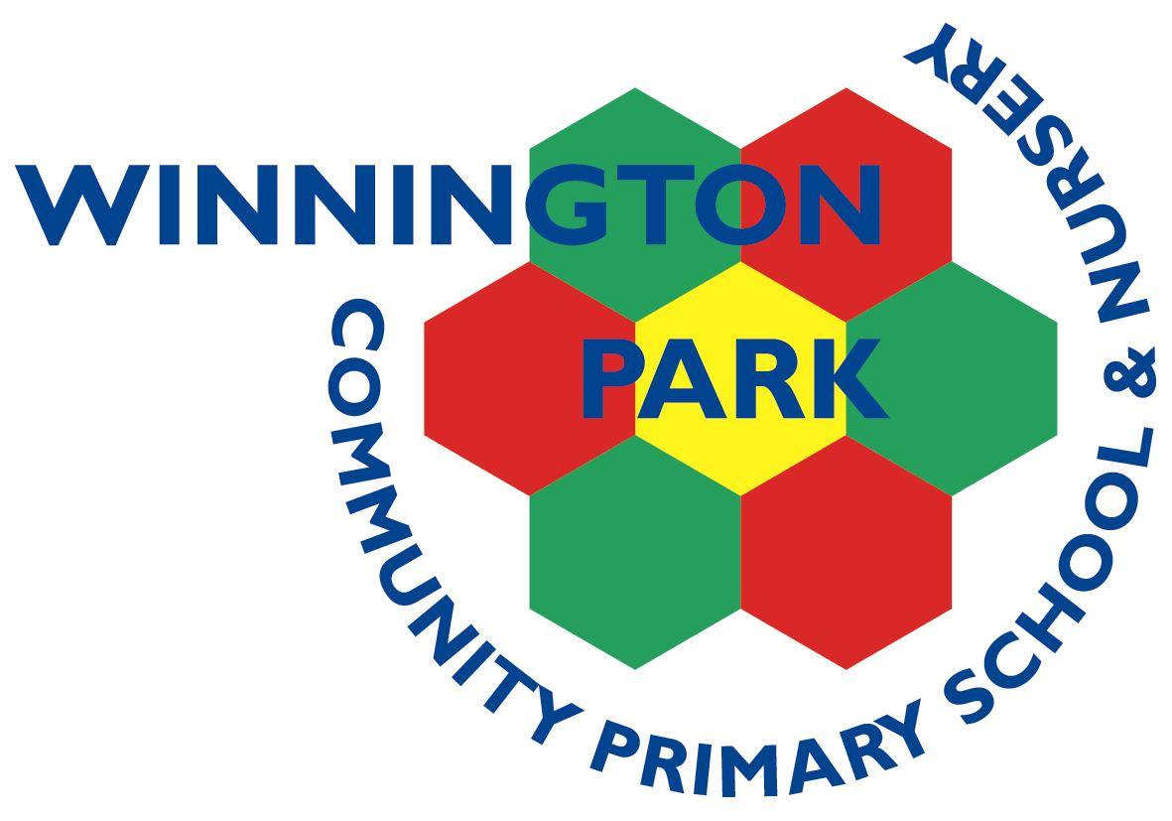

|  |  |  |  |  |  |
| --- | --- | --- | --- | --- | --- |
| ***ASPIRE*** | ***SAFE*** | ***TRUST*** | ***RESPECT*** | ***KIND*** | ***PRIDE*** |

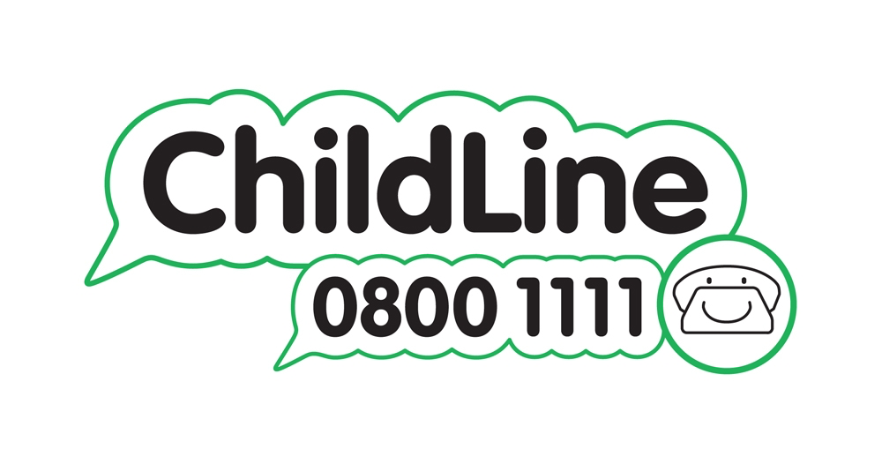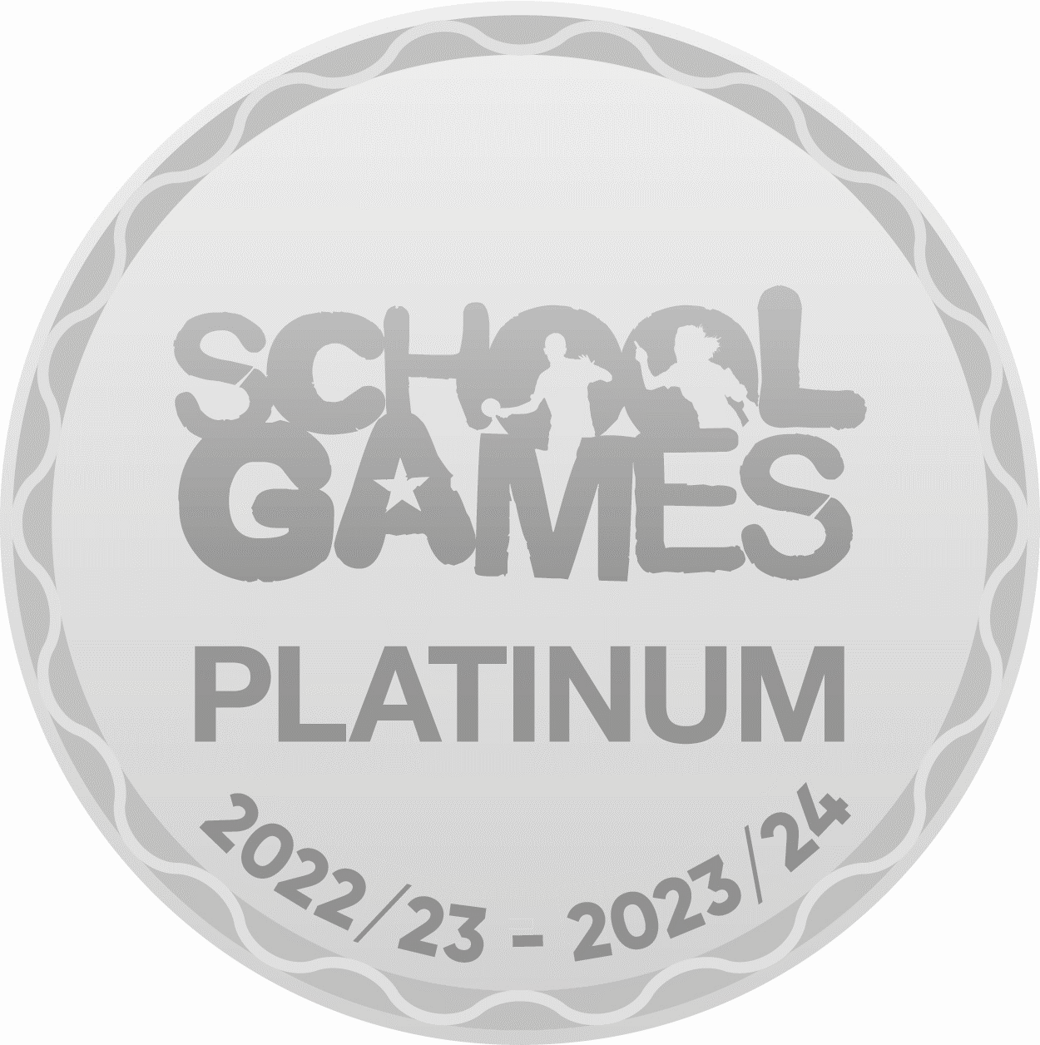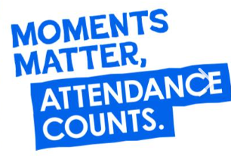

Wednesday 9th October 2024

Dear Parents and Carers,

**R.E Trip to the Northwich Muslim Cultural Centre**

As part of our R.E. curriculum we have arranged to visit the Northwich Muslim Cultural Centre in Northwich on Wednesday 23rd October. We will be leaving school at 9:15am and walking to the centre. We will return to school at approximately 11:45am in time for lunch.

During the session, the children will learn about the main beliefs of Islam and the five pillars. There will also be a chance for the children to ask questions.

We are asking for a small donation of £1 per child for the session, which will need to be returned to your child’s class teacher alongside the permission slip.

Please return the permission slip by Friday 18th October. We welcome parent volunteers to accompany us on our trip. If you are available, and would like to join us, please indicate this on the slip.

Yours sincerely,

Mrs Flackett and Miss Croucher

_______________________________________________________________________________________

**Year 5 visit to the Northwich Muslim Cultural Centre in Northwich**

I give permission for my child______________________________________ to attend the Northwich Muslim Cultural Centre.

I give permission for my child’s photograph to be taken and I understand that it may go onto the school’s website and Facebook page and also be shared in the press.

Signed_________________________________ Contact: _________________________

I am able / not able to help walk the children to the Northwich Muslim Cultural Centre.

Winnington Park Primary School and Nursery, Firdale Road, Winnington, Northwich, Cheshire, CW8 4AZ

Tel: 01606 74371 email: admin@winningtonpark.cheshire.sch.uk website: www.winningtonpark.cheshire.sch.uk

Head teacher: Mr Rob Cole email: head@winningtonpark.cheshire.sch.uk

