

|  |  |  |  |  |  |
| --- | --- | --- | --- | --- | --- |
| ***ASPIRE*** | ***SAFE*** | ***TRUST*** | ***RESPECT*** | ***KIND*** | ***PRIDE*** |

**Year 3/4 Netball After School Club**

Dear Parents, Carers and Children,

We are excited to announce that we are able to offer the opportunity to take part in our netball after school club run by Nikki Sherriff, a local netball coach.

Sessions will run every Monday until half term (7 weeks) 3:15pm - 4:15pm, starting on Monday 9th September. Children will need collecting promptly from the gate which leads to the school field at 4:15pm.

To secure your place in the club, an upfront payment of £35 cash (£5 per session) will need to be paid to Nikki on the first session.

Please ensure your child brings a water bottle and their PE to school which they will get changed into at the end of the day. Warm clothing (a jumper, leggings/joggers) may be required as the sessions will be held outdoors.

To book your child’s place please contact Nikki Sherriff on 07834964159.

Places will be allocated on a first come, first serve basis.

Yours sincerely,

Mrs Williams



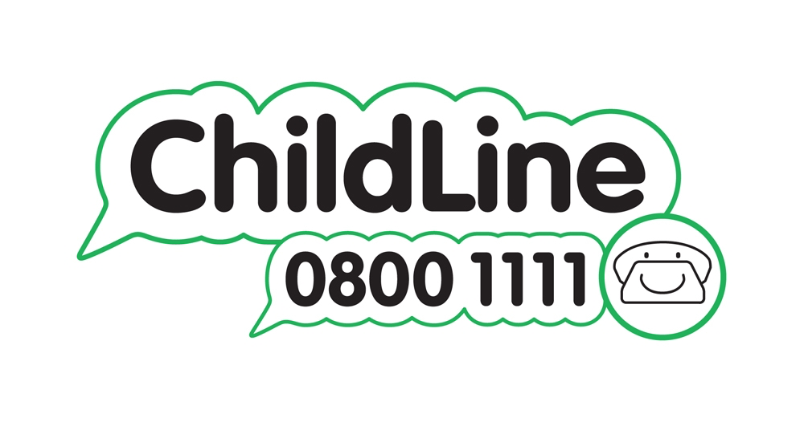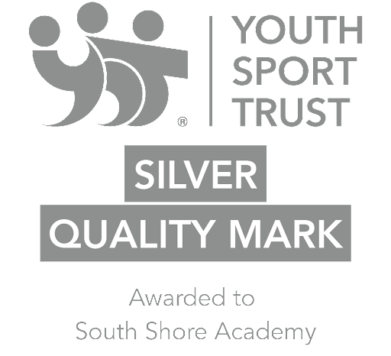

Winnington Park Primary School and Nursery, Firdale Road, Winnington, Northwich, Cheshire, CW8 4AZ

Tel: 01606 74371 email: admin@winningtonpark.cheshire.sch.uk website: www.winningtonpark.cheshire.sch.uk

Headteacher: Mr Rob Cole email: head@winningtonpark.cheshire.sch.uk