

|  |  |  |  |  |  |
| --- | --- | --- | --- | --- | --- |
| ***ASPIRE*** | ***SAFE*** | ***TRUST*** | ***RESPECT*** | ***KIND*** | ***PRIDE*** |

**Reception Dance After School Club**

Dear Parents, Carers and Children,

We are excited to announce that we are able to offer the opportunity to take part in our dance after school club run by Alicia Millington, a local dance teacher (Buckley Theatre School).

Sessions will run every Thursday (7weeks) until the Christmas holidays 3:15pm - 4:00pm, starting on Thursday 7th November. Children will need collecting promptly from the gate which leads to the school field at 4:00pm.

To secure your place in the club, an upfront payment of £35 cash (£5 per session) will need to be paid to Alicia on the first session.

Please ensure your child brings a water bottle to school. The children will not need a change of clothes but they are welcome to bring a pair of trainers if they would like. The sessions will be taking place in the Key Stage 1 hall with the support of EYFS staff.

To book your child’s place please contact Alicia Millington 07853149034.

Places will be allocated on a first come, first serve basis.

Yours sincerely,

Mrs Williams



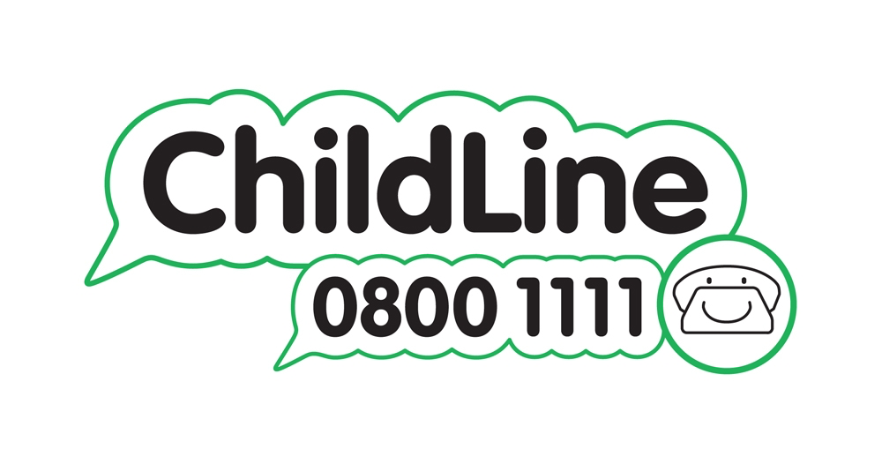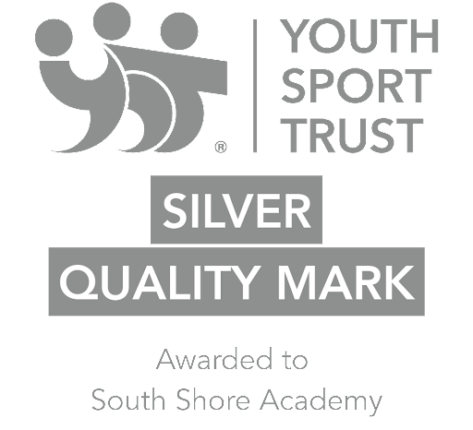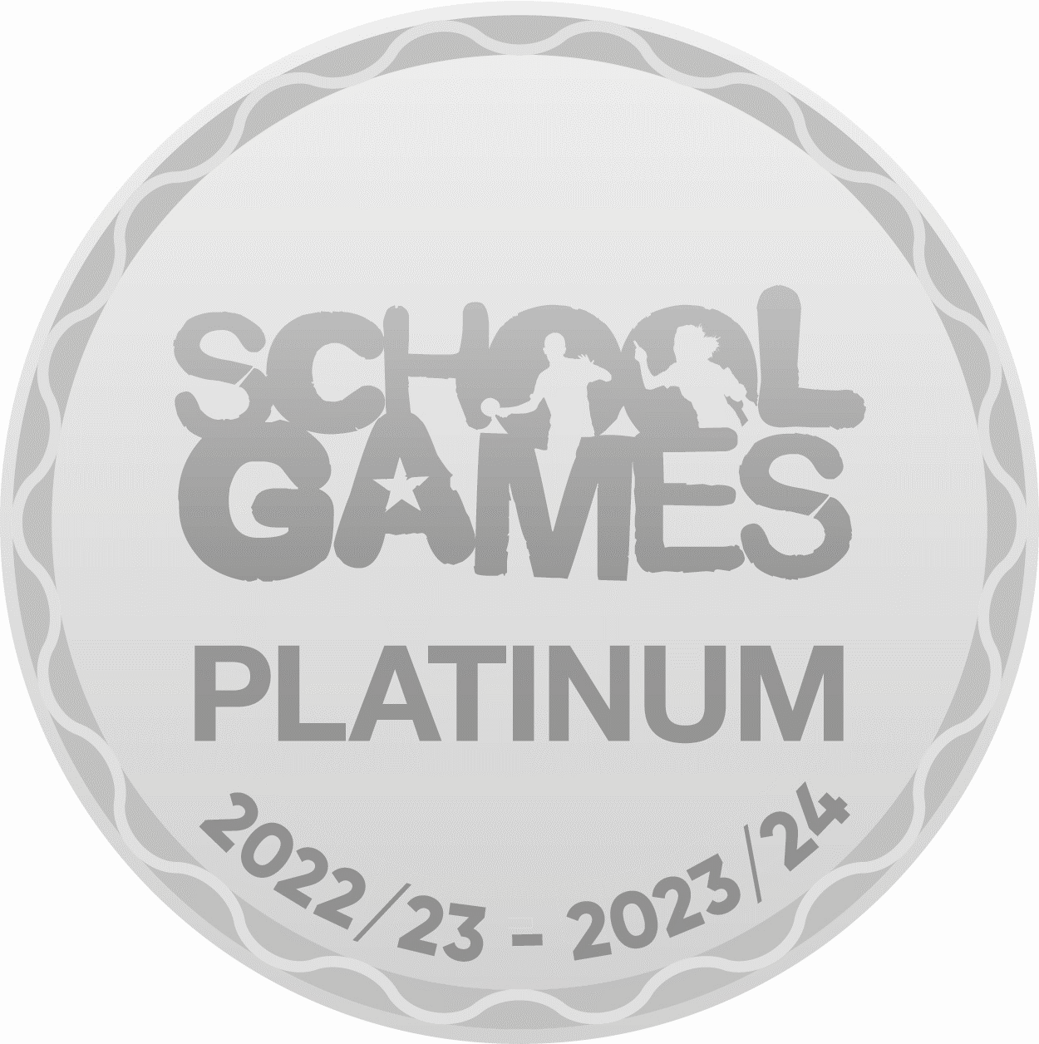

Winnington Park Primary School and Nursery, Firdale Road, Winnington, Northwich, Cheshire, CW8 4AZ

Tel: 01606 74371 email: admin@winningtonpark.cheshire.sch.uk website: www.winningtonpark.cheshire.sch.uk

Headteacher: Mr Rob Cole email: head@winningtonpark.cheshire.sch.uk