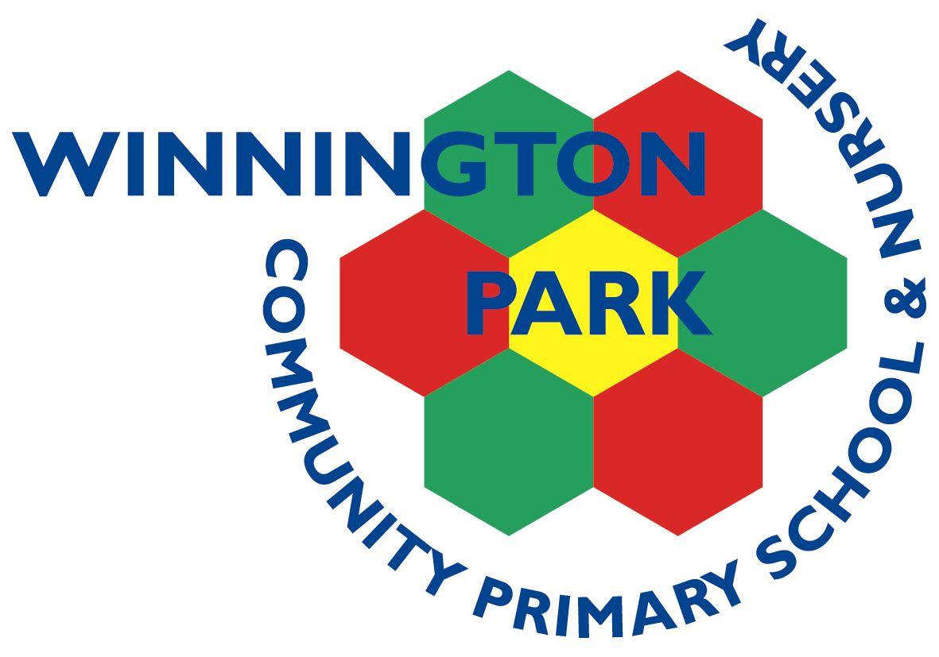

|  |  |  |  |  |  |
| --- | --- | --- | --- | --- | --- |
| ***ASPIRE*** | ***SAFE*** | ***TRUST*** | ***RESPECT*** | ***KIND*** | ***PRIDE*** |

Monday 11th November

Dear Parents and Carers,

**Northwich Lanterns Parade and Christmas Lights Switch On – Year 4 Invitation**

Year 4 have been invited to take part in this year’s Northwich Christmas Lanterns Parade on Saturday 23rd November.

Today we have received confirmation of the event details from the Town Council (otherwise we would have notified of you of the details sooner).

Please see the attached letter.

A local artist is coming into school this week to make lanterns with the children and they will carry these on the parade. It will be a lovely event and was very exciting last year to be standing ‘on stage’ during the countdown for the Christmas light switch-on. It will be fantastic if you are able to come along and support this local event.

Please return the reply slip to school to let us know if you think you will be able to attend.

Kind regards,

Mr Rob Cole

*(Headteacher)*

Please return to Mrs Worsley or Mrs Conheeney

My child ___________________________________ in class _________________

Will be attending the lanterns parade on Saturday 23rd November from 4.00pm and will be accompanied on

the route by _______________________________________

Signed parent/carer ___________________________________ date _____________________

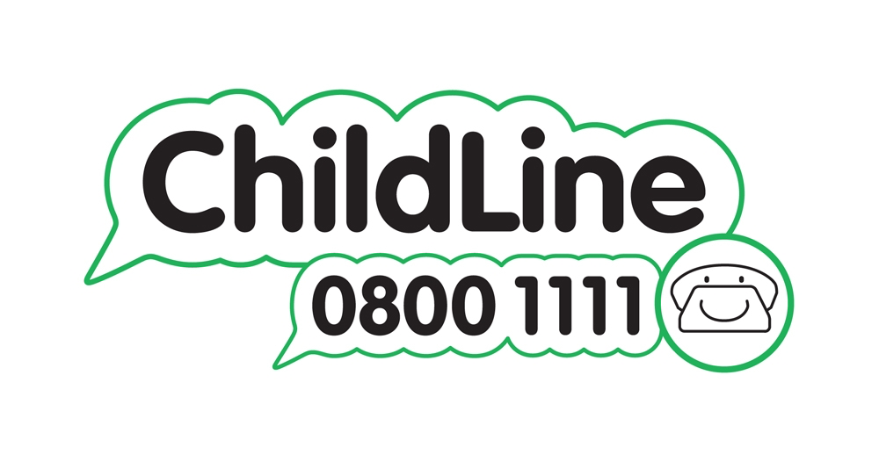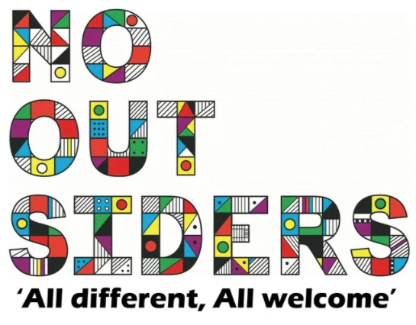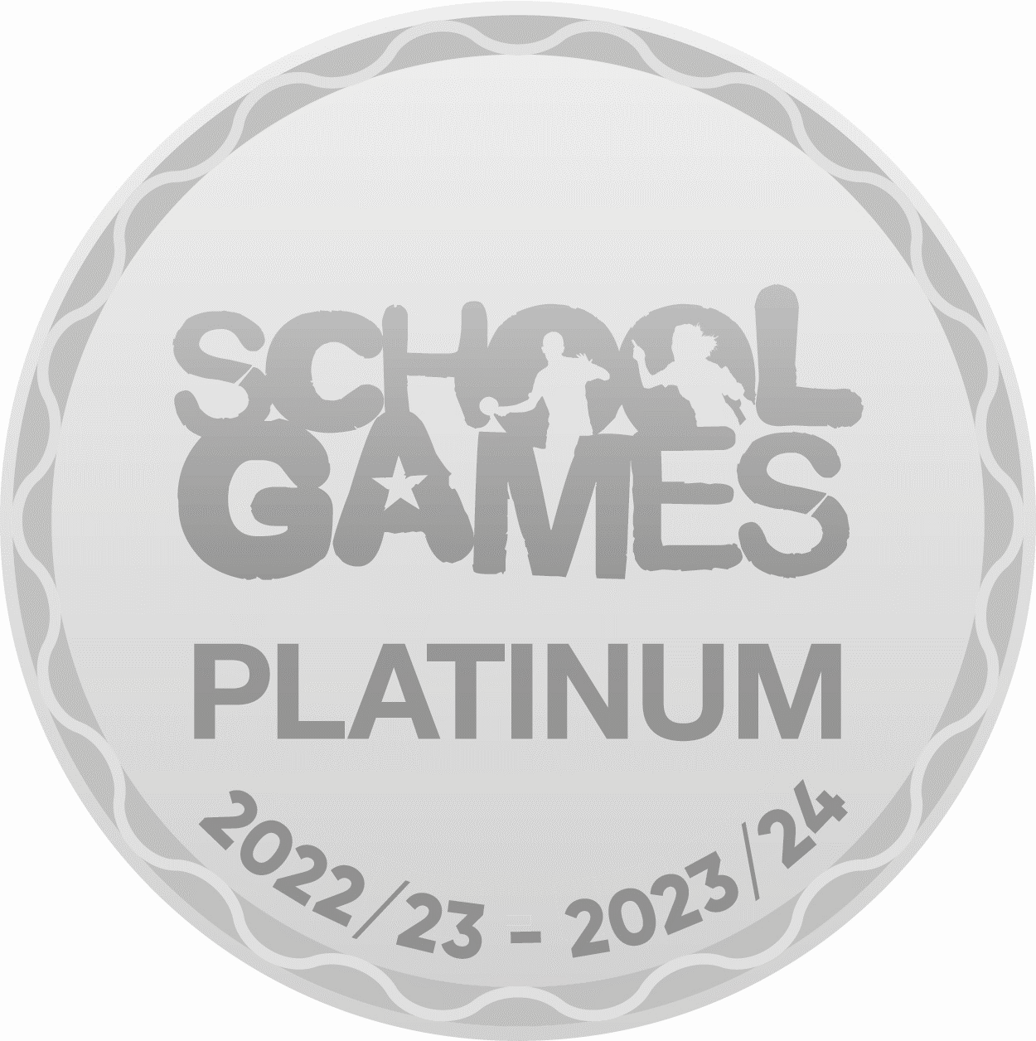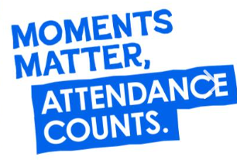

Winnington Park Primary School and Nursery, Firdale Road, Winnington, Northwich, Cheshire, CW8 4AZ

Tel: 01606 74371 email: admin@winningtonpark.cheshire.sch.uk website: www.winningtonpark.cheshire.sch.uk

Headteacher: Mr Rob Cole email: head@winningtonpark.cheshire.sch.uk

