**GROUNDING TECHNIQUES**

Children sometimes get easily frustrated and struggle to manage their anxieties or frustration. Grounding techniques are used to help manage these stressful feelings of emotions and concerns that may cause increased anxiety. They are used by a wide variety of individuals, and work differently for each person. What might work for one individual may not work for another.

Grounding techniques are best learnt when you or your child are in a state of calm. This will give them the opportunity to learn the technique that works for them without the pressures of increased anxiety or stressful situation.

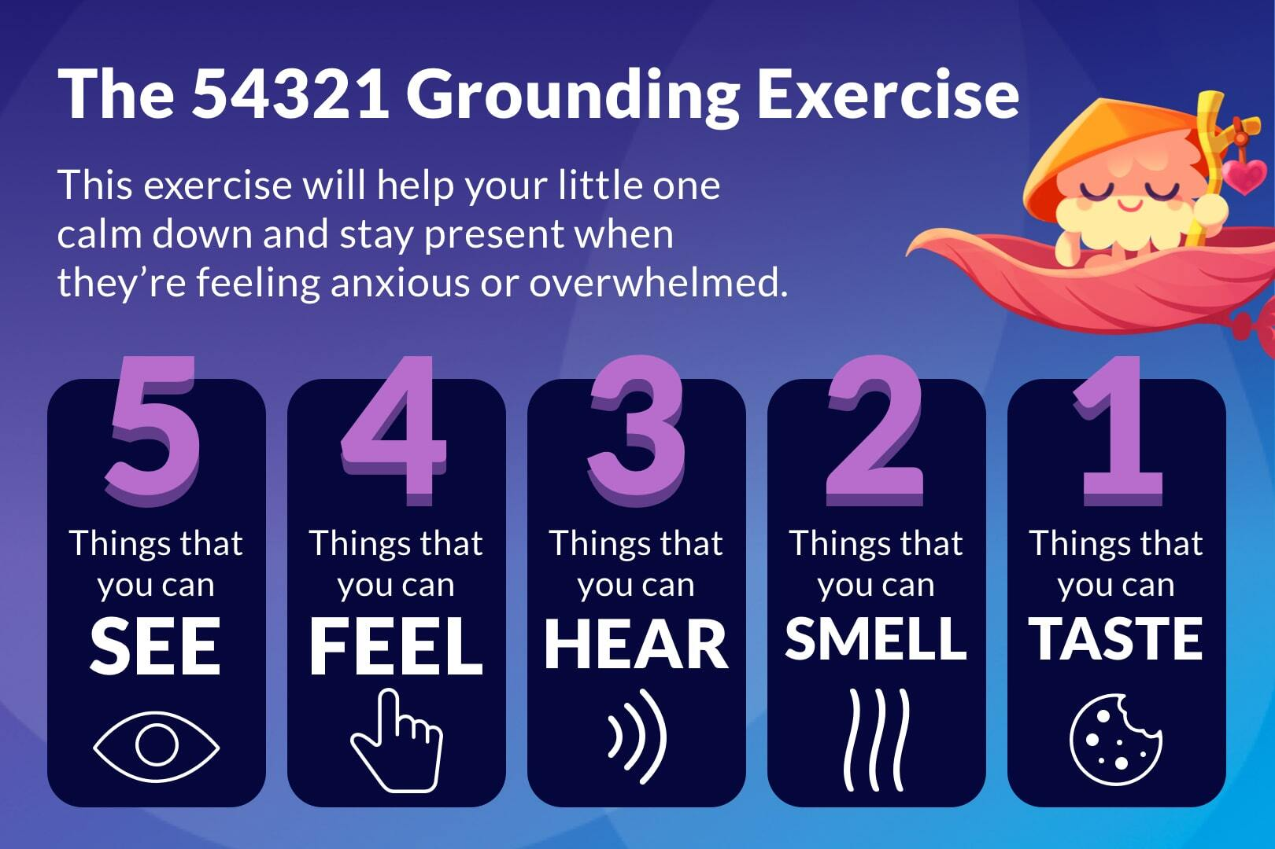

**Here are some examples of grounding techniques:**

1. **5-4-3-2-1 Technique -** Using the 5-4-3-2-1 technique, you would aim to use your surroundings to redirect yourself.
2. **Category Counting -** Chose a category of interest to you and your child, it could be films, countries, books, cars, flowers, animals, ect. Try and name as many items as you can that will fit into that category. To vary the naming of each items try and name them in alphabetical order. For example, fruit: Apple, Banana, Cucumber, ect.
3. **Body Awareness -** Try and bring your body into the present. Work from your toes up to your head. For example:

* Wiggle and move your toes around on the floor or in your shoes.
* Rotate your ankles, point your heels down and then back up to the ceiling.
* Flex and extend your knees.
* Rotate your hips around, bend forward and back, side to side.
* Rotate your hands and fingers around.
* Extend your arms out in-front, to the side, and above your head.
* Rotate your shoulders forward and backward.
* Rotate your head around, look up to the ceiling and down to the floor.
* Finally give your whole body a gentle shake.

1. **Redirection -** Tracking the environment around you. Can you find 5 blue things in the room? Can you find 5 circular shapes? Can you find something in that room beginning with each letter of the alphabet.
2. **Positive Thinking -** Make a list of positive things that bring you joy.
3. **Humour -** Try and think of different funny scenes from a film or TV show? Try and picture your favourite cartoon or real life character in a film.
4. **Use an anchoring phase -** You can make this sentence as long or as short as you like. You can make it personal to you.

This might be something like..

**‘My name is …. I am …. years old. I live in …. town. Today is …. and it is …. in the morning/evening.**

1. **Visualisation -** Envisage yourself in a safe place, this could be at home in your bedroom, or sat with a family member at the park. Close your eyes and work through each of your senses to imagine that you are in that safe place. Describe or picture the surroundings, think about how you would feel.

Calming kit with items your child may find relaxing. 

1. **Create a calming strategy** - Create a calming kit – find something that your child finds relaxing. This could be a comforting blanket, a pleasant sensory stimulation from a lavender cushion or headphones with their favourite calming music to help redirect them.
2. **Deep breathing techniques** - Encourage your child to take nice, long, slow deep breaths. Inhale for 1,2,3 seconds then exhale for 1,2,3 seconds. Repeat this 5 times, then return to normal breathing as deep breathing for a prolonged period of time may cause light headedness.

**Please be aware that our service does not cover anxiety/grounding techniques and if you should seek any further information please visit the:**

<https://www.livewell.cheshirewestandchester.gov.uk/>