**CONCENTRATION AND ATTENTION**

Concentration is the ability to focus and sustain your attention on a task, whilst memory is the ability to recall and retain information that has happened in the past. Concentration and memory have many parts, for example memory involves short term, long term and working memory, whereas concentration contains sustained attention, multitasking and focused attention.

Both concentration and memory are vital for a child’s development, they play a critical role for children engaging in school, learning and participation at the same level of their peers. Poor concentration or attention can lead to challenging behaviour, whereas poor memory may result in your child struggling to retain the information covered in previous classes, which may have an impact on their learning. There is a large link between concentration and memory, if you can't concentrate long enough to focus on the information it will be more challenging later on to correctly remember this information.

As children progress through school it is expected that they are required to focus for longer periods of time. As a result, it’s important to look for signs that suggest your child is having difficulty focusing on the task.

Some of the most common indicators include:

* Staring into space
* Unable to maintain a train of thought
* Needing instructions repeated several times
* Fidgetiness
* Not listening when spoken to

Today, the attention spans of children are decreasing due to the amount of time they spend online or using a technology device like a tablet or a smartphone. These computer games are designed to engage children's minds from the start. Although an app on a computer or tablet can be beneficial particularly when traveling in a car, they often disengage children in other functional tasks.

**ACTIVITIES FOR IMPROVING ATTENTION**

Concentration and memory games are activities that require the child to use their concentration skills and/or memory skills.

The best concentration activities for children are those that encourage the child to think while doing the activity.



* **Building Activities** - Helps improve attention span and concentration to give children a goal. It gives the child a visual representation of their achievements.
* **Memory Games** - Choose a memory game that uses 3-D shapes or picture cards to appeal to all learning styles. Activities include ‘snap’, ‘go fish’, ‘what’s missing’ are excellent games.
* **Puzzle Games** - puzzles are great for your children’s mind and cognitive development. Puzzles provide an opportunity for a child to develop fine motor skills, improve hand-eye coordination. It is important to grade the activity dependant on your child’s abilities. Activities include: matching shapes and colours, jigsaw, Rubik cube, spot the difference and mazes.
* **Timed Activities** - Timed games and classwork are not only versatile activities to improve concentration in children, but are very appealing to students because they want to win and beat the timer.
* **Sequencing Activities** – Sequencing an activity may use a variety of senses to encourage engagement in the activities. Kitchen based activities with the support of parents are beneficial. For example, baking, this requires you to follow a recipe (either written or pictorial) which results in an overall outcome that you can eat.
* **Cooking Activities** - Great in class and home activities that help children focus longer are following recipes, baking or decorating cookies. If appropriate for your children's ages and ability levels consider giving small groups simple recipes to follow. Try to give students different ingredients to measure and mix.
* **Quiet Time Activities** - Children need frequent breaks to refresh. These breaks help improve their levels of concentration and focus. Young children would benefit from a quiet area in their classroom or at home where they can take naps. While older students need breaks, nutritious snacks and meals, and free time.

**TIPS FOR IMPROVING CONCENTRATION**

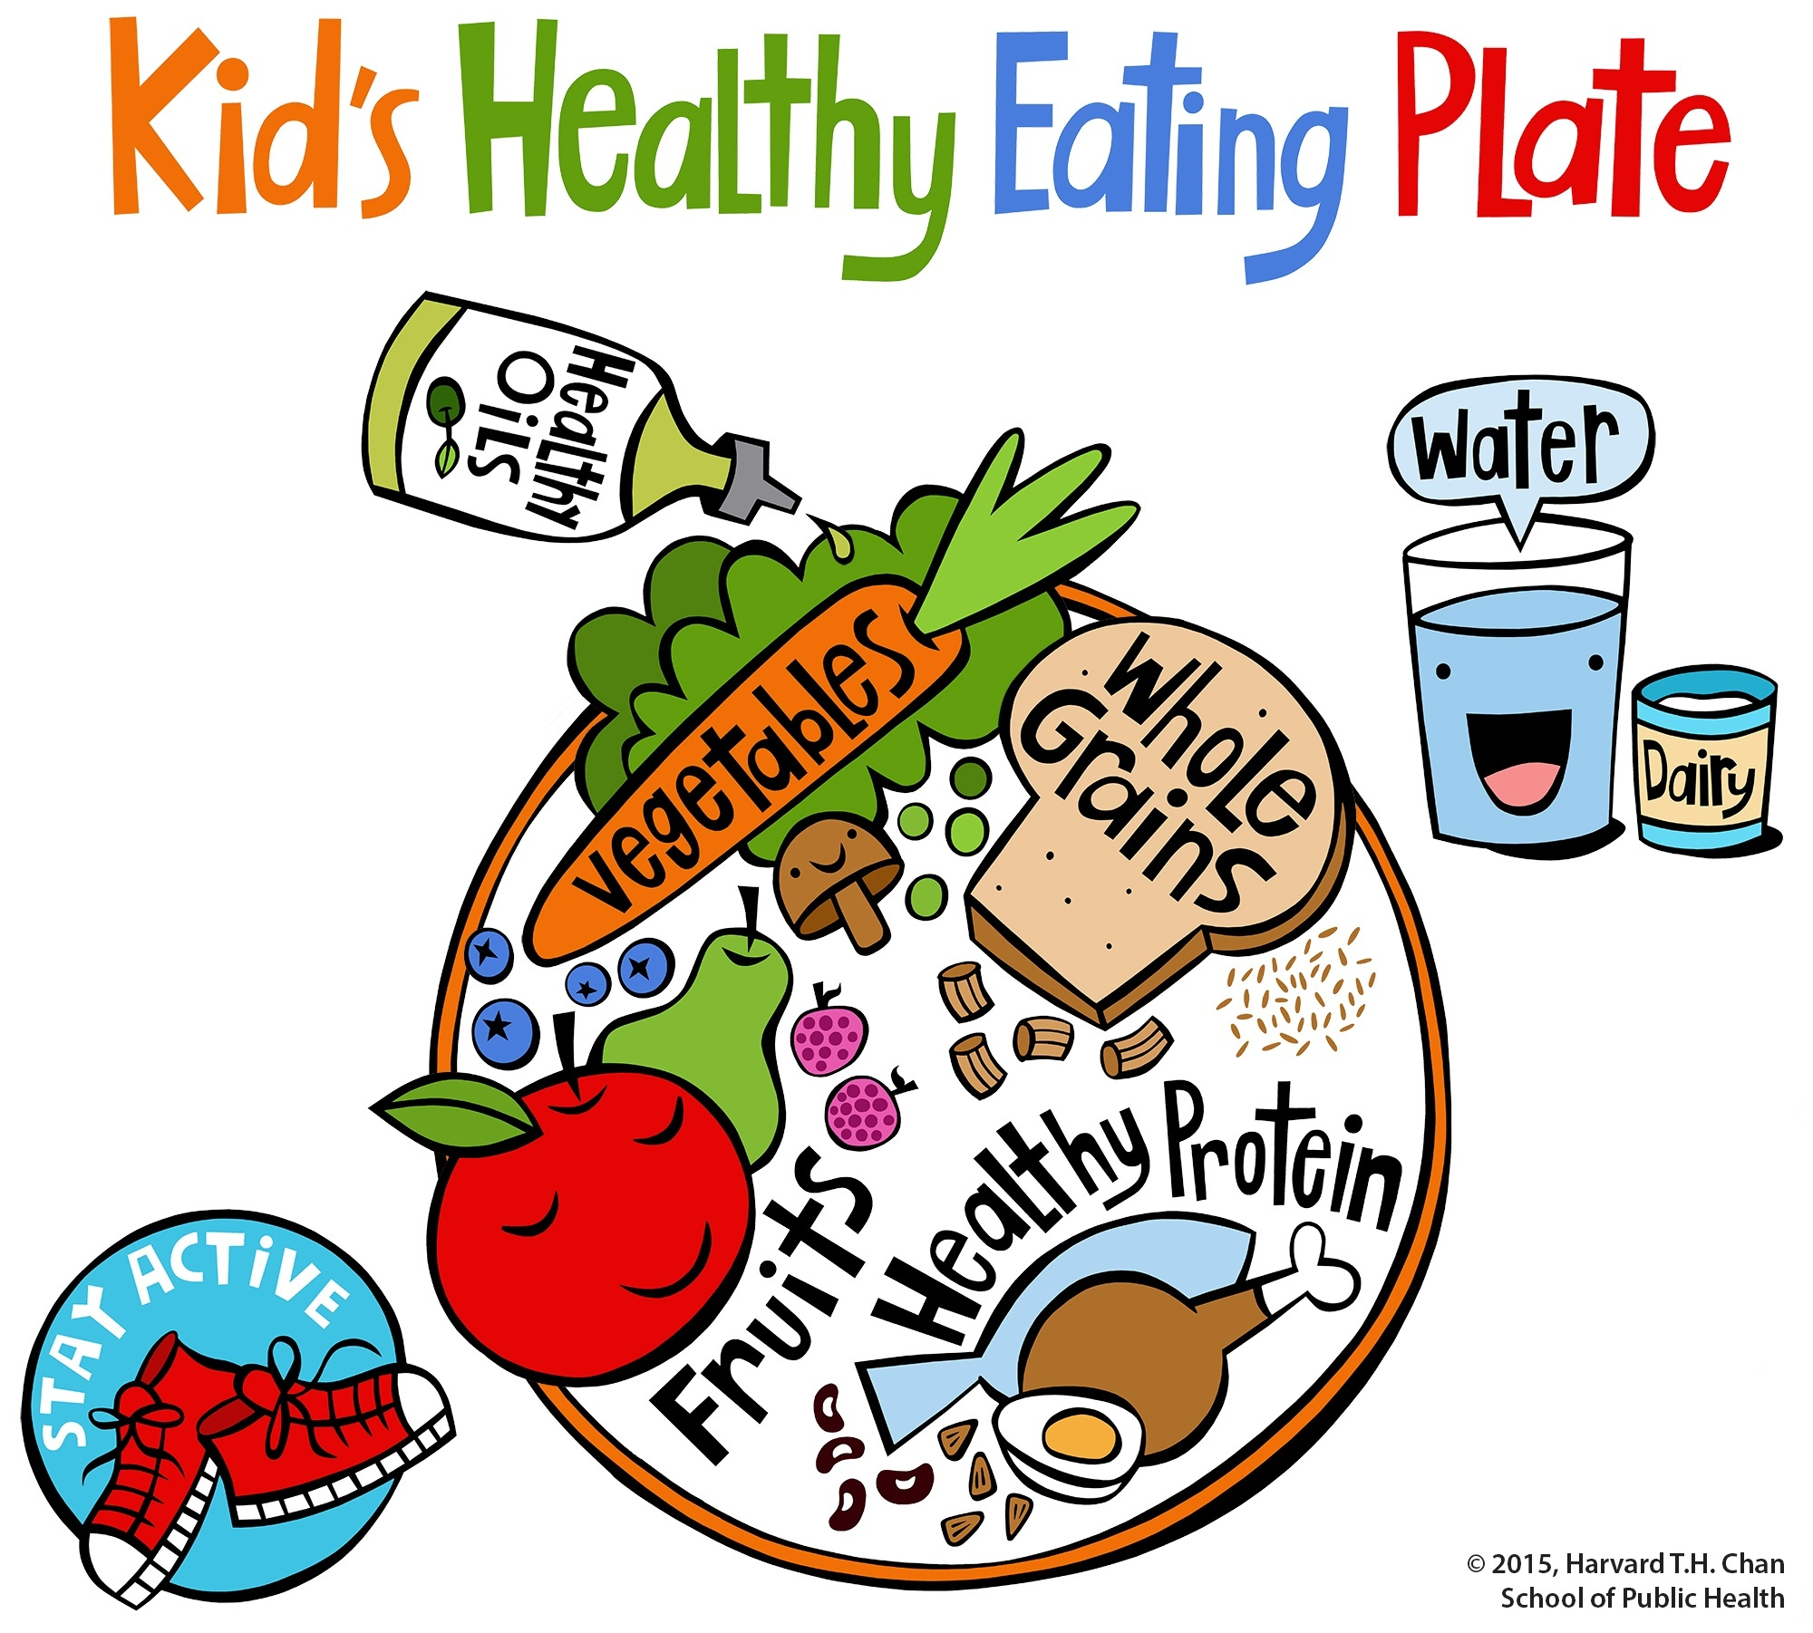

**Healthy diet** – Eating health food has a direct link to how well a child concentrates. Junk food or foods rich in sugar can make a child sluggish, whilst foods rich in protien like fish, eggs lean meat raise awareness.

**Fix a routine** – Helps with time management but also programmes your childs body to know what activity the body should be doing at each time. Eg. A child knows that after school they have 30min to relax and have a snack before thsy need to do homework.

**Bild in nap time** – Gives the body time to relax prior to completing a task.

**Divide big tasks into smaller more manageble tasks** – Studying an entire chappter or book in one go is challenging. It always helps to break the task down into smaller parts. It gives the child a sense of atchievement once they have completed the task and will motivate them to carry on.

**Understand you childs method of learning** – All children learn differently, having an idea to how your child learns will help them understand information better in the long run.

**Prepare your child for the next task** – When your child is busy, tell them what is expected next. Give them a few minutes to finish what they are doing before moving on with another task.

**Set short term goals** – Use the SMARTER goal setting technique. Allow the child enough time to complete the task, whilst ensuring they have the knowledge to be successful, whilst still needing to concentrate on the task.

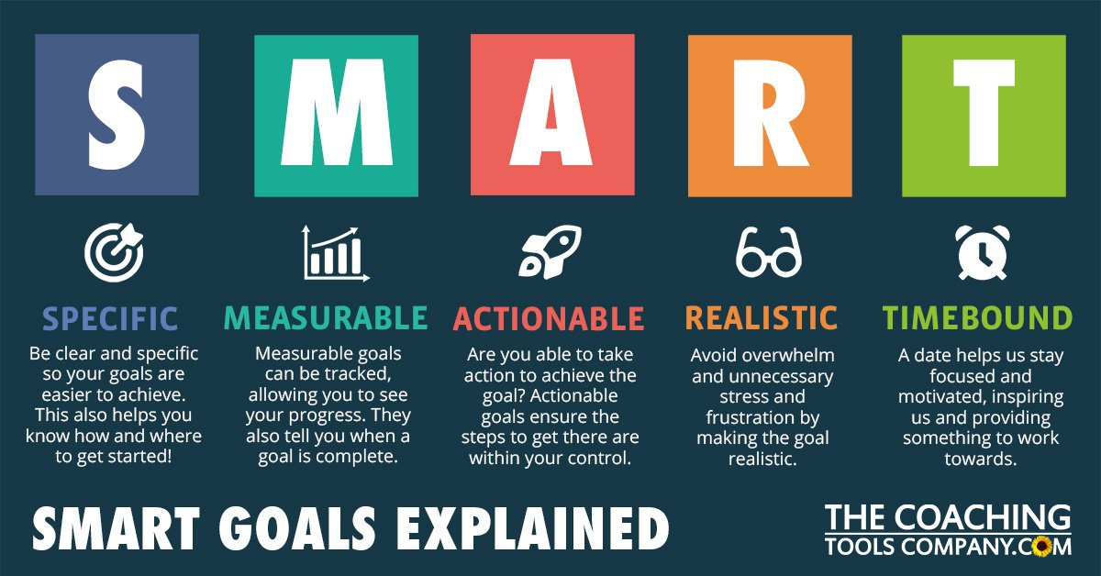

**Set up a reward system** – Positive reinforcement.

**Allow time for distraction** – Children are naturally energetic. Giving them time to vent out their energy once their time limit for a task is up may help them focus better on the next task!

**Use energy more efficiently** - Some children have higher energy in the morning, others in the evening. Studying or doing activities during this time will help your child focus better on the task at hand. Always start your child on the tougher activities during their high energy time. As energy levels go down, you can always switch to a lighter activity. This will help to increase concentration power!

**Please be aware that our service predominantly looks at functional skills and if you should seek any further information on concentration and attention please visit the web link bellow:**

<https://www.livewell.cheshirewestandchester.gov.uk/>