**STARTING BACK AT SCHOOL FOLLOWING THE COVID-19 PANDEMIC**

While back-to-school is typically a time of excitement, it's normal for children to experience some degree of anxiety as a new school year approaches. Younger children may get nervous about leaving their parents, and older children may worry about academics or how they'll fit in with their friends after spending time apart during summer. This year, COVID-19 might add to those stresses as children worry about themselves or their loved ones becoming ill. Many normal routines will change as schools take precautions to prevent the spread of COVID-19. The uncertainty of the situation and changes in routine can cause many students and parents to feel stressed and anxious.

**Signs that your child might be anxious in returning to school**

Children may show their anxiety in different ways. You know your child best, so be on the lookout for changes in your child's behaviour and mood, such as:



* Increased defiance or irritability
* Disturbances in sleep
* Loss of appetite
* Lack of concentration
* Less energy
* Physical symptoms like nausea
* Refusal to go to school
* Sadness or crying

**How can you help as a parent or guardian?**

If your child is experiencing anxiety related to school or COVID-19, it's important to discuss their feelings and have open and honest conversations. How you help your child as they transition back to school may depend on what type of anxiety your child experiences and what age they are. For example, children under age 12 are more likely to have separation anxiety and might need reassurance about being away from a parent. Older children may feel unsure about how changes might affect their social connections or feel frustrated by perceived limitations on their freedom or how their learning has been affected.

**It might be beneficial to:**

* Check in with your child frequently and listen to their concerns. Make sure to validate their emotions, letting them know that their concerns and frustrations are understandable.
* Ensure your child is getting enough sleep, being physically active and eating healthy food to support a healthy body and mind.
* Encourage your child to do more of what they enjoy most, whether this is reading, playing outside or other activities.
* While plans may continue to change, explain to your child what you do know about what the school year or classroom will look like to help them mentally prepare.
* If your child is going to participate in virtual or remote learning, take steps to set them up for success academically, physically and emotionally.

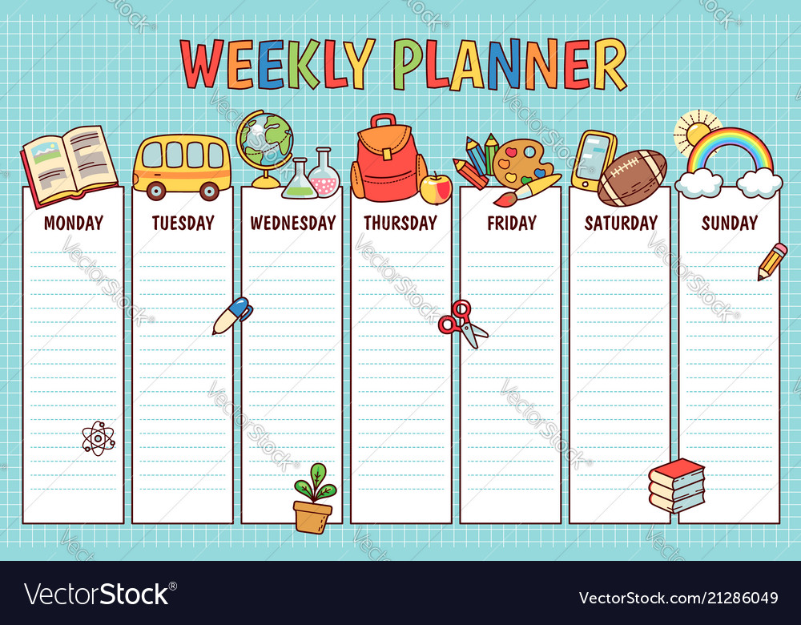

* Whether your child will be returning to school in person or virtually, it is important to ease them back into a structured daily routine and sleep schedule.
* If possible, visit your child's school ahead of the first day of classes or allow your child to meet their teacher in a social distancing situation.
* Set up ways for your child to continue to socialize safely with their friends over the phone or video chat, especially if they participate in distance learning.
* Teach your child breathing exercises they can do when they feel anxious.
* Send positive or encouraging notes in your child's lunch or backpack.
* Try and rationalise your thoughts. For example, I have worked hard at home, therefore I will be at the same stage as others in my class. I am washing/sanitising my hands often, which means that I am helping keep myself and others around me safe.
* Develop a routine of getting back into school
* Gradually introduce your child back into the school environment. Maybe attend school for half a day, and gradually increase the time you spend at school.
* Create a safe place for a child to go when their anxiety levels are high.
* Allow a few minutes before and after school for your child to transition from the home to school environment.
* Incorporate fun meaningful activities into the days’ events.
* Encourage the teacher to use positive self-talk to encourage and praise the children for their efforts.
* As a parent, if you are anxious, you can try to reduce this by working with the teacher or school in advance with a meeting to discuss any questions or concerns.

**Techniques to reducing levels of anxiety that have materialised from the Covid-19 pandemic**

* Be a role model for your child re all the precautions that are in place, for example, practice good hand hygiene, wearing a mask, keeping your distance and talking about how you are feeling.

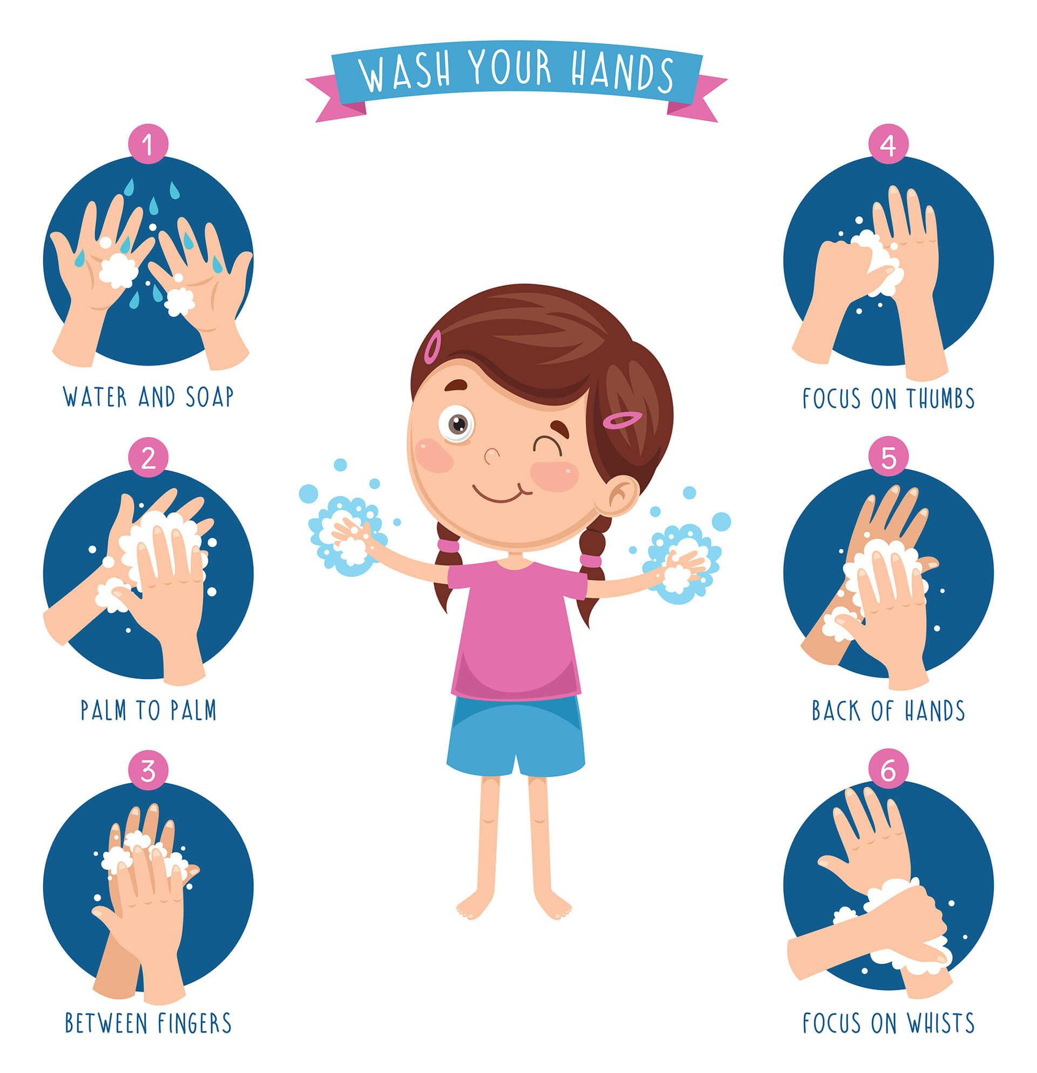

* Help your child focus on what they can control in the fight against the pandemic, such as hand washing, wearing a face mask and practicing social distancing.
* Help your child adjust to COVID-19 precautions such as wearing a face mask. It is okay to empathize with your child if they find wearing a mask uncomfortable. Let them know that although it can be unpleasant at times, wearing a mask is an important way we can help protect others.

**Please be aware that our service does not cover anxiety management and if you should seek any further information please visit the:**

<https://www.livewell.cheshirewestandchester.gov.uk/>

**Additional advice and support can be found at:**

<https://youngminds.org.uk/find-help/conditions/anxiety/?gclid=EAIaIQobChMI7e_QmpKc8QIVDNPtCh18hQxHEAAYAiAAEgL18PD_BwE>

Text message support time:<https://www.snow-camp.org.uk/stopbreathethink/?gclid=EAIaIQobChMI9sXHuZKc8QIVm-vtCh1oyQq9EAAYAiAAEgKSqvD_BwE>

Success club - <https://www.successclub.org.uk/?gclid=EAIaIQobChMIibDG8ZKc8QIVAe_tCh2ydQ4AEAAYASAAEgKTxfD_BwE>