

|  |  |  |  |  |  |
| --- | --- | --- | --- | --- | --- |
| ***ASPIRE*** | ***SAFE*** | ***TRUST*** | ***RESPECT*** | ***KIND*** | ***PRIDE*** |

Tuesday 26th November

**Key Stage 2 Carol Concert Evening – Thursday 12th December 5.30pm**

The children in key stage 2 will be learning some popular Christmas carols and songs over the coming weeks and on Thursday 12th December at 5.30pm, we invite them back to school with their families for a whole school carol singing event.

We shall start the event with some carols played by our talented Year 6 Orchestra and the PTA will support the event by selling mulled wine, mince pies, hot chocolate and other refreshments.

The whole school community is invited to attend, (whether you have children in key stage 2 or not) to join in the singing and celebrate the time of year together. Carol singing will start at approximately 6pm but we hope to see you there earlier to enjoy the refreshments.

The event will be outside on the playground, so fingers crossed we have dry weather. If it is raining heavily, the event will be held on the afternoon of Tuesday 17th December at 2pm in the Dane Hall but will only be open to the families of children in key stage 2. Further information will be shared about this contingency plan if required.

Children in key stage 2 should wear their school uniform and will need to be dressed warmly in coats, gloves, hats etc. Christmas accessories are encouraged! Please park on the Moss Farm car park – the gates to the school field will be open. Children should not attend the event without a family member or other adult who is supervising them.

Please return the reply slip so we can plan appropriately. We really hope you will be able to support this Christmas tradition and join together as a whole school for some festive cheer and celebration.

Yours sincerely,

Mr Rob Cole

*(Headteacher)*

______________________________________________________________________________

**Please return to your child’s class teacher**

My child _________________________________ in class ________________________

Will be attending the key stage 2 carol singing evening at school on Thursday 12th December at 5.30pm

I give / I do not give permission for their photograph to be taken and shared on the school’s social media

Signed _____________________________________ date ________________

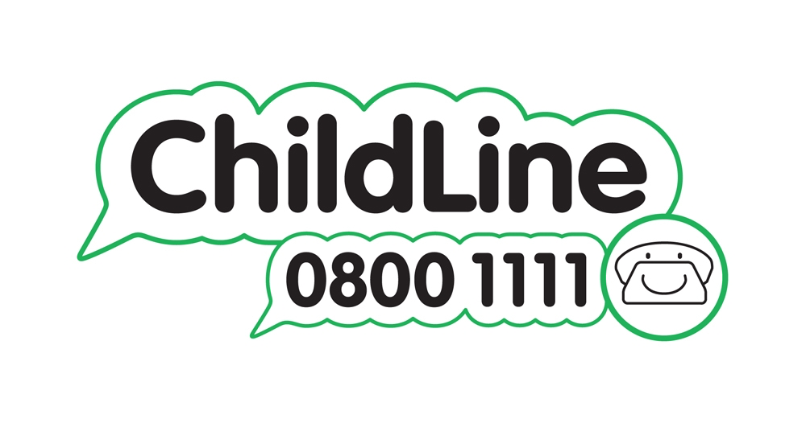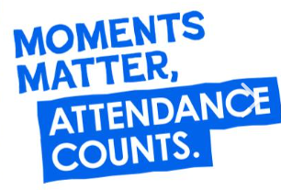

Winnington Park Primary School and Nursery, Firdale Road, Winnington, Northwich, Cheshire, CW8 4AZ

Tel: 01606 74371 email: admin@winningtonpark.cheshire.sch.uk website: www.winningtonpark.cheshire.sch.uk

Headteacher: Mr Rob Cole email: head@winningtonpark.cheshire.sch.uk

