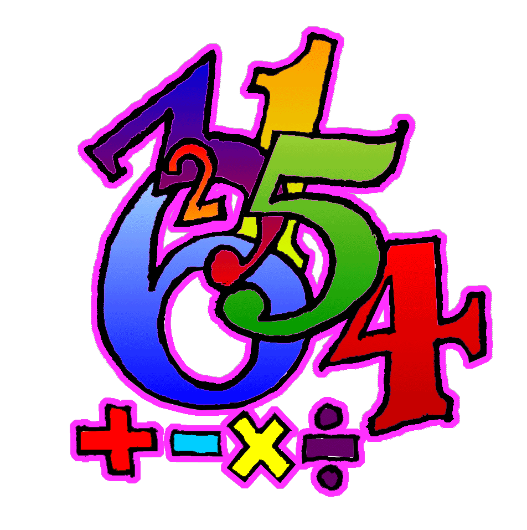
Number Facts Homework Challenge
Learn your number facts at home every week. You will be tested on a Friday Morning. This will be in any order.
The number facts focus this half term is quick doubles and halves.
Test: 17.01.25 | Test: 24.01.25 | Test: 31.01.25 | Test: 07.02.25 | Test: 14.02.25
Doubles to 7  Double 1  1 + 1 = 2  Double 2  2 + 2 = 4  Double 3  3 + 3 = 6  Double 4  4 + 4 = 8  Double 5  5 + 5 = 10  Double 6  6 + 6 = 12  Double 7  7 + 7 = 14 | Doubles to 14  Double 8  8 + 8 = 16  Double 9  9 + 9 = 18  Double 10  10 + 10 = 20  Double 11  11 + 11 = 22  Double 12  12 + 12 = 24  Double 13  13 + 13 = 26  Double 14  14 + 14 = 28 | Halves to 14  Half of 2  1  Half of 4  2  Half of 6  3  Half of 8  4  Half of 10  5  Half of 12  6  Half of 14  7 | Halves to 28  Half of 16  8  Half of 18  9  Half of 20  10  Half of 22  11  Half of 24  12  Half of 26  13  Half of 28  14 | Halves and doubles timer test  Revisit all

