

|  |  |  |  |  |  |
| --- | --- | --- | --- | --- | --- |
| ***ASPIRE*** | ***SAFE*** | ***TRUST*** | ***RESPECT*** | ***KIND*** | ***PRIDE*** |

Tuesday 7th January 2025

Dear Parents, Carers and Children,

**Spring Term Welcome**

We hope that you all enjoyed a relaxing Christmas break and are ready for the New Year! The Year 6 topic for this term is ‘British Monarchs’. Throughout this topic, children will learn about the history of the royal family from the Tudors and their impact on the history of England, to the modern British Royal family. Links will be made across the curriculum where possible.

With the May SATs at the forefront of all the work we shall be doing this term, we hope the following information will be useful to you in supporting your child to achieve their full potential.

To support children during the lead up to SATs, targeted homework will be set each Friday with a focus on Maths, Grammar and Punctuation. Children will be required to complete a series of pages of practice questions in their CGP ‘SATS Buster’ books. Although reading comprehension homework is not set, it is imperative that your child continues to read daily at home. We will continue with weekly spellings and your child will be tested every Friday. Please encourage and support your child to complete their homework at home and to return their books to school on time. If your child needs extra support with their homework, please come and speak to us before the due date and we will happily help.

Music lessons will still be on a Monday and PE days will be Tuesdays and Fridays. Please ensure your child comes into school in their PE kit on those days.

|  |  |
| --- | --- |
| Monday | * Bring instrument for music lessons. |
| Tuesday | * Wear PE kit. |
| Friday | * Wear PE Kit. * **Homework is due and set for the following week.** * Spelling test. |

A meeting specifically about the SATs tests will be held later in the term. However, should you have any concerns or queries in the meantime, please do not hesitate to get in touch.

Yours sincerely,

Mrs Hall and Mrs Williams

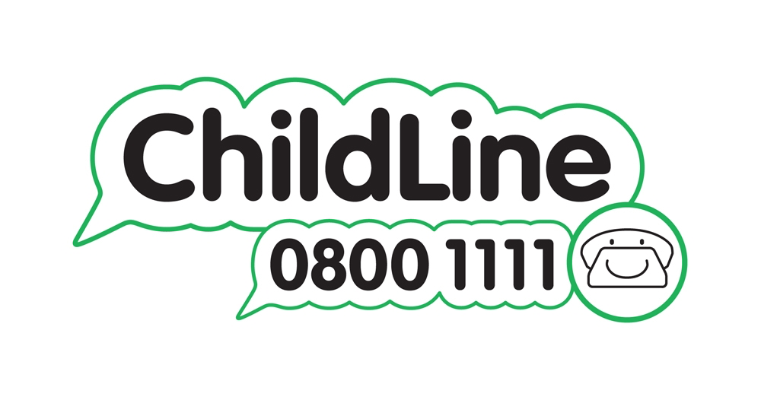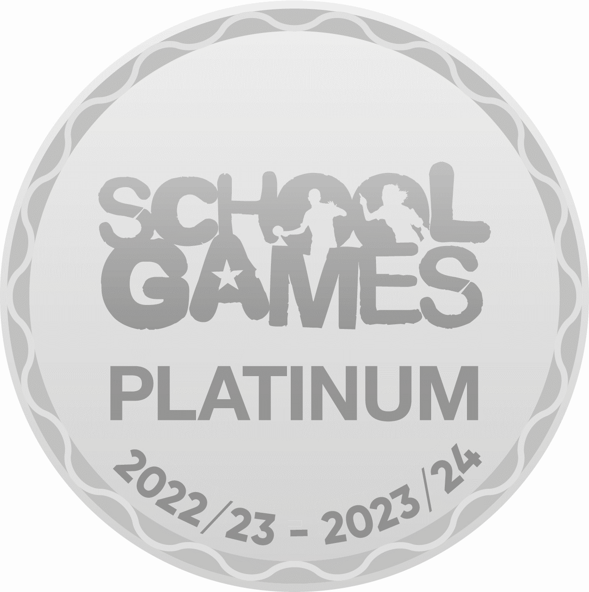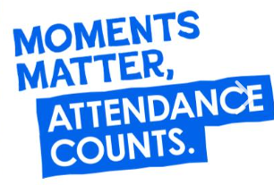

Winnington Park Primary School and Nursery, Firdale Road, Winnington, Northwich, Cheshire, CW8 4AZ

Tel: 01606 74371 email: admin@winningtonpark.cheshire.sch.uk website: www.winningtonpark.cheshire.sch.uk

Headteacher: Mr Rob Cole email: head@winningtonpark.cheshire.sch.uk

