Multiplications
In Year 2, we need to know multiplication facts for the 2x, 5x and 10x tables. Ones to start learning are the 10x table below. The children will complete a timed challenge each Friday that will be in any order. Once they are confident with the 10x table they will move onto the 5x and then the 2x table. We will send your child home with a 5 x table sheet when they are ready to move onto the 5s.
First test will be Friday 28th February
x 10
0 x 10 = 0
1 x 10 = 10
2 x 10 = 20
3 x 10 = 30
4 x 10 = 40
5 x 10 = 50
6 x 10 = 60
7 x 10 = 70
8 x 10 = 80
9 x 10 = 90
10 x 10 = 100
11 x 10 = 110
12 x 10 = 120

Ways to learn your times tables
Websites
These links are on the school’s website

https://www.topmarks.co.uk/maths-games/5-7-years/multiplication-and-division
https://www.timestables.co.uk/games/
https://www.timestables.co.uk/
http://www.maths-games.org/times-tables-games.html
Purple Mash has lots of games like 2Simple Table Toons, Monster Multiplications and Maths City.

Making arrays
Arrays are a way of arranging objects into equal rows and columns. Make arrays using pasta, playdough, pebbles or even sweets!
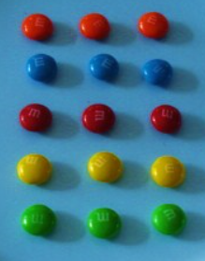
3 x 5 = 15
3 groups of 5

Against the clock
Write or say the times table as quickly as you can. Have a go at writing and saying it in order and then in a random order.

