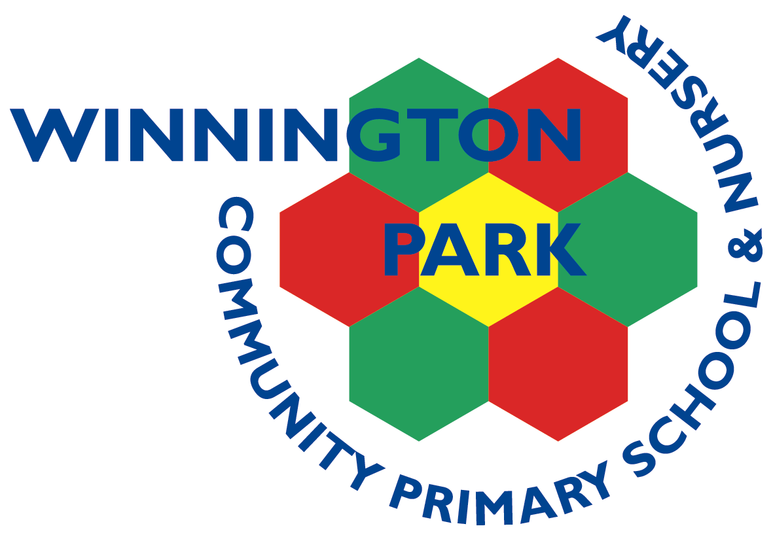
Remote Education Provision Information For Parents at Winnington Park Primary & Nursery School January 2021

Remote Education Support
Information was sent to parents in September 2020 with information regarding the remote learning platform and how to access it. Parents were asked for their permission to set up a Google email account and asked to register.
During Autumn term 2020 homework was set on Google Classroom for all users to become familiar with the platform. Tapestry is used as an electronic learning platform for children in EYFS. This has been used for a number of years and families are accustomed to this process as Learning Journeys.

Well Planned and Sequenced Curriculum.
The knowledge and skills being taught remotely will continue with the planned curriculum for each year group in key stage 1 and key stage 2 and the Early Years Curriculum for children in EYFS, progressing from the point where classes were up to when remote learning began. Children with SEND who have top-up funding or an Education and Health Care Plan will have learning opportunities tailored towards them achieving their individual targets. Interventions will be organised and where possible delivered remotely to children working from home. Where a group of children are being taught remotely, in parallel with their year group peers who remain in school, every effort will be made to ensure that these children receive the same offer of education and do not fall behind their peers.

How Much Work Will Be Provided For Children Each Day?
‘The remote education provided should be equivalent in length to the core teaching pupils would receive in school and will include both recorded or live direct teaching time, and time for pupils to complete tasks and assignments independently. The amount of remote education provided should be, as a minimum:
•Key Stage 1: 3 hours a day on average across the cohort, with less for youngerchildren
•Key Stage 2: 4 hours a day’
DfE January 2021

Accessing remote education
EYFS – Tapestry
KS1 & KS2 - Google Classroom, Bug Club Reading
Oak Academy, First 4 Maths, Literacy Counts, The Literacy Company, NCETM, Maths Hub, Science Hub resources.

We recognise that some pupils may not have suitable online access at home. We take the following approaches to support those pupils to access remote education:
- Contact school in first instance 01606 74371 or email head@winningtonpark.cheshire.sch.uk
- We may be able to loan you digital device
- We may be able to access additional internet access
- We can provide paper copies of work

How will children be taught remotely?
We use a combination of the following approaches to teach pupils remotely:
- Recorded audio recordings made by teachers
- Recorded video made by Oak Academy
- Workbooks/work sheets
- Textbooks
- On-line schemes eg Bug Club
- Commercially available websites for specific subjects
- Membership to partnerships eg Vale Royal School Sports Partnership, Youth Sport Trust

Engagement and feedback

At Winnington Park we advise children to work remotely in line with their classroom routine. 1 hour of Literacy; 1 hours maths; 30 minutes reading;30 minutes phonics/spelling’ 30 minutes physical activity; and foundation subjects for the rest of the time.

Through their online interactions with children and their families, through Tapestry entries and through the submission of pieces of work, teachers will be able to make judgements about the progress children are making with their learning. All work that children complete and ‘turn in’ to their teacher will be acknowledged. Children will have three Maths assignments and three English assignments assessed in more detail each week and will receive a ‘next steps’ suggestion for each of these pieces of work. Work from the previous day will be marked in line with the policy, retrospective work will be acknowledged. Tapestry entries that children complete will be acknowledged, commented upon and next steps will be provided as appropriate.

Additional support for pupils with particular needs
We recognise that some pupils, for example some pupils with special educational needs and disabilities (SEND), may not be able to access remote education without support from adults at home. We acknowledge the difficulties this may place on families, and we will work with parents and carers to support those pupils in the following ways:
Children with SEND who have top-up funding or an Education and Health
Care Plan will have learning opportunities tailored towards them achieving
their individual targets.

Remote education for self-isolating pupils
Where individual pupils need to self-isolate but the majority of their peer group remains in school, how remote education is provided will likely differ from the approach for whole groups. This is due to the challenges of teaching pupils both at home and in school.

Appendix 1

Information Letters to Parents September 2020 to Set UP Google Classroom

http://www.winningtonpark.cheshire.sch.uk/serve_file/764182

http://www.winningtonpark.cheshire.sch.uk/serve_file/783040

Appendix 2

Remote Learning Policy Winnington Park Primary & Nursery School

http://www.winningtonpark.cheshire.sch.uk/serve_file/763763

